# ENROLLMENT SYSTEM FOR MANTALONGON NATIONAL HIGH SCHOOL- DALAGUETE, CEBU

A Capstone Proposal Presented to

The Faculty of the Department of computer, Information Sciences and Mathematics University of San Carlos

In Partial Fulfillment

Of the Requirements for the Degree CERTIFICATE IN COMPUTER TECHNOLOGY

Prepared by: BAYUTAS, MA. JUSTINE Y. MAMARINTA, ABDUL AZIS D.

MONCEDA, JOSELITO J. TELEZ, MERY-AN A.

CHRISTIAN MADERAZO M. ENG.

Adviser

DECEMBER 2021

i

# ABSTRACT

Technology is everywhere, at work, at school and at home. Thus, the educational system has taken advantage of technology in teaching and learning, record keeping and in their enrollment system.

As such, Mantalongon National High School, as a growing public secondary school in Dalaguete, Cebu, slowly adapts to the enhancement of technology in the area and replaces their manual enrollment process with a hybrid one.

This Enrollment system for Mantalongon National High School is a computer-based system that is fast, accurate, reliable and easy to use and is designed for school’s administrators and teachers. The system will enable authorized users to provide an updated, secured and easy to access student records and generate accurate report cards.

The system was developed through a modified waterfall model and the technology used for both frontend and backend side is Laravel.

|  |  |
| --- | --- |
| **TABLE OF CONTENTS** |  |
| **ABSTRACT** | **ii** |
| **TABLE OF CONTENTS** | **iii** |
| **LIST OF FIGURES** | **v** |
| **LIST OF TABLES** | **vi** |
| **CHAPTER INTRODUCTION** |  |
| **1.1 Rationale of the Study** | **1** |
| **1.2 Statement of the Problem** | **4** |
| **1.2.1 General Objective** | **4** |
| **1.2.2 Specific Objectives** | **4** |
| **1.3 Significance of the Study** | **4** |
| **1.4 Scope and Limitations** | **5** |
| **CHAPTER 2 RELATED SYSTEMS** | **6** |
| **CHAPTER 3 TECHNICAL BACKGROUND** | **33** |
| **CHAPTER 4 DESIGN AND METHODOLOGY** | **35** |
| **4.1 Conceptual Framework** | **35** |
| **4.2 Analysis and Design** | **37** |
| **4.3 Development Method** | **41** |
| **4.4 Development Approach** | **42** |
| **4.5 Software Development Tools** | **43** |
| **4.6 Project Management** | **44** |
| **4.6.1 Schedule and Timeline** | **44** |
| **4.6.2 Responsibilities** | **45** |

4.6.3 Budget and Cost Management 46

4.7 Verification, Validation and Testing 46

BIBLIOGRAPHY 48

# APPENDICES

**Appendix A Transmittal Letter Appendix B Interview Guide Appendix C Questionnaire**

**Appendix D Software Requirements Specifications CURRICULUM VITAE**

**LIST OF FIGURES**

# Figure 1: Current Process Conceptual Framework Model 35

# Figure 2: New Process Conceptual Framework Model 36

# Figure 3: Use Case Diagram for Admin 38

# Figure 4: Use Case for Teachers 39

# Figure 5: Entity Relationship Diagram 40

# Figure 6: Development Model 41

# Figure 7: Development Approach 42

# Figure 8. Gantt Chart for First Semester 44

# Figure 9. Gantt Chart for Second Semester 45

# Figure 10: Team Structure 45

**LIST OF TABLES**

**Table 1: Detailed Comparison Matrix 30**

**Table 2: Software Development Tools 43**

**Table 3: Responsibilities 46**

**Table 4: Budget and Cost Management 46**

**Table 5: Questionnaire 60**

**CHAPTER 1 INTRODUCTION**

* 1. **Rationale of the Study**

The period that the technology arises is known to be the new era especially in the field of education. Technology brought a wide variety of opportunities in building lighter loads of educators and learners (Harris et. al., 2016). As mentioned by Miranda (2019), advancement of technology is taking its step one day at a time to provide solutions for the limitations of the human race. These innovations are made by people for the people to help in making everyday jobs easier. Information systems were being upgraded to handle more complex and large data; one of them is the Enrollment System. As the school increases in its enrollees every year, the harder it becomes to deal with, particularly in public academic institutions wherein the population of the students is massive. Improvement in technologies and learning never ends, as well as the educational system (Panganiban,2020). It revolutionized the field of education therefore its importance cannot be ignored by schools for it made the process of teaching learning all the more efficient (Cuebas; Kumar, 2021). According to Raja & Nagasubramani (2018), there are four aspects of education that technology has positively affected: technology as part of curriculum, as an instructional delivery system, as means of providing instruction and also as a tool to enhance the entire learning process.

Truly, there are numerous advantages that technology imparted to our educational institutions. It is evidenced by the tools and systems that were built and continuously experimented to be developed (Then, 2006). Since the enrollment process is one among the most important transactions performed by schools which involve the various transactions, enrollment systems’ usage is extremely common nowadays (Abad et. al.; Gasteiger, 2011). Additionally, the enrollment system is an organizational concept and a scientific set of

activities designed to enable educational institutions to exert more effort over their student enrollments (Sentina & Luna, 2009).

Nowadays since the pandemic started it is really hard for some of the students to enroll themselves through the internet, since most of them don't have good internet connections and mobile phones to use, hence this enrollment system indeed plays a vital role for the schools and for the teachers.

De Guzman et. al. (2017) therefore stated that it answers the emerging needs of most schools of well-integrated processes that can perform much faster and more accurately than a manual system.

Considering the tedious task of filling out the admission form and the inaccuracies of information provided by the students, the traditional enrollment process is indeed taking time (KUPDF.net, 2016). These factors cause enrollment delays, which is disadvantageous to the enrollment personnel and as well as the students (Agustin, 2017). A manual enrollment system also resulted in a lot of challenges in handling school transactions resulting in more serious problems like unreliable records of the scholars and data losses (PaperAp.com, 2018; Cayabyab, 2016). Enrollment-related documents that need to be tracked and maintained during and after the enrollment process is a plus to the workload (SCHOOLMINT COLLECTIVE, 2016). The traditional enrollment process is known to be a very stressful time for school personnel and students considering that yearly students of schools are sometimes unpredictably increasing (PhDessay.com, 2017). With this, the implementation of an offline enrollment system is considered because such a system has to be capable of handling the surge of network connections from the student’s population during the admission period by just a use of a computer device and a database (Darunday, 2016).

This is what the Mantalongon National High School Principal has come to realize most especially that as the years passed by, the school flourished with consistent growth and development thus able to cater the needs of

education of the youth in the area. What adds to the concern of the school is when the Department of Education implemented the K to 12 Enhanced Basic Education Program fully in the school year 2016-2017 and Senior High School was added in the formal education (Palafox et. al., 2018). Hence, the implementation of the K to 12 Curriculum also led to the increase of student students not only in the Senior High School, but also in the Junior High School Department (Acar, 2017). As the number of students increases, the enrollment procedure also becomes tougher (INetTutor.com, 2016; Cogal, et. al., 2019).

Gladly, there is a tool that could serve as a guide for students to enroll faster, reduce redundancy for enrollment staff in manually validating information filled up and boost productivity (Palit-ang, 2014; StudyMoose, 2016). However, this form of computer-mediated process in enrolling is adding interesting new dimensions to regular school learning especially with its flexible access using the internet (Posey, et. al.). Such a system ensures to transform the existing traditional paper-based complex enrollment process into an enrollment-friendly, efficient, time-saving, accurate, and transparent system at an affordable cost with greater speed and wider accessibility (Fedena, 2019).

With this essential, the proponents proposed an enrollment system for Mantalongon National High School which will help overcome the school’s need for less hassle, less time consuming and even more productive enrollment process. The implementation of the system in the school will also lessen the school personnel’s effort in dividing the students into different sections as it will automate the students’ section designation. Thus, it will also provide flexibility because the admin could always have the rights to navigate the different modules of the system like adding a new section of a specific grade level, adding a new teacher assigned in a section, and most especially view schedules and print the files being uploaded by the teachers. The teachers have an individual account wherein they are the one who will enroll and store the student’s information in the system and assign the students to their designated sections. At the end of every quarter or semester, the teachers can

give their grades to the students using the system and the system will automatically generate the report cards of every student.

# Statement of the Problem

Mantalongon National High School Enrollment System is a system that provides different services to the staffs of the said school.

Specifically, this study aims to provide of the following problems:

* + 1. The teacher will take lot of time in finding and accessing student’s data because it is being store in a cabinet after enrollment.
    2. The teacher has to exert lots of efforts in designating the students into their designated sections
    3. It takes time in inputting the student’s grade in the excel manually and printing them one by one.

# General Objective

This study aimed to provide Mantalongon National High School an Enrollment System which includes features for: Section designation, teacher scheduling, generate report card and most importantly, an Enrollment for an easier enrollment process.

# Specific Objectives

The specific objectives in conducting this study are the following:

* + - 1. Investigated the process of enrollment in Mantalongon National High School - Dalaguete Cebu
      2. Less time consumed in printing report cards of students
      3. Easier section designation
      4. View and print teacher schedules
      5. Designed and developed the system that fits their specific needs

# Significance of the Study

The main output of this project will be beneficial to the following stakeholders:

***Mantalongon National High School****.* It will eventually raise the quality of services offered by the school.

***Faculty and Enrollment Staff****.* The system will ultimately lessen the burden of the staff most especially in storing and retrieving enrollment data, assigning the students into different sections, viewing their specific schedules every section they handled and the manual input of grades and the printing of report cards of the students.

***Proponents.*** It will help the proponents’ skills improve by being able to experience developing a real project and get them ready in the corporate world.

***Future researchers.*** It will eventually be used as their review of related systems and can be a guide for development.

# Scope and Limitations

This study focused on designing and developing an enrollment application for Mantalongon National High School with an automated section designation and the giving of grades every end of the semester, quarter or school year. It is a web application that could be accessed by 3 types of users (admin, advisory teachers and non-advisory teachers).

We also have here the following limitations of our system. The system is developed only for MNHS Staff and the system caters to the enrollment and process of giving grades to the students from one teacher to another.

# CHAPTER 2 RELATED SYSTEMS

This chapter presents the studies and systems that show similarities to the Enrollment System for Mantalongon National High School. This review helps to evaluate how the enrollment systems in other areas work and how it affects their institutions.

According to [www.scribd.com,](http://www.scribd.com/) (2011) enrollment is the process of entering and verifying data of students to register at a particular school. Different interrelated processes build up enrolment procedures called Enrolment System (ES). ES are used particularly in recording and retrieving student information. Tracking student information is also one feature of ES, in which the school can trace the standing of a student. Verifying payment was also added to update or browse student billings. Enrollment System is a good example of a computer-generated process. This can lessen the workload and provide accurate information.

Moreover Garcia (2002) – the study can be a great help to persons concerned during the enrollment period, the registrar, instructor of the students as they retrieve necessary information when needed and lessen the burden manually browsing over enrollment slips for record purposes.

Furthermore, these major concerns are affecting the efficient enrollment of students. Security of the students' records were found to be at high risk. It may fail to protect some important documents. It also has untimely and inefficient report generation. A computerized for (DNHS) shall result in a significant increase in the number of enrollees Cayabyab (2007).

Billy Thomas (2010) Computerization of every process reduces human errors and processing time, it can also boost up productivity. “Computers are the best means for storage and management of data, they can serve as huge

knowledge bases and can be harnessed for all sorts of financial transactions owing to their processing power and storage capacities. As computers are a daily utility, they have gained immense importance day-to-day.

According to Dzubeck, Frank (2003) is a broad system. It is a combination of different functional areas such as databases, searching, retrieval, and update of student records, checking of students’ schedule, and computation of fees. Inspired by the advancement of modern technology and the problems regarding enrolment transactions the proponents have come up with an online enrolment system exclusively for schools with many enrollees. Several factors are considered in designing the proposed system. First is the tedious task of filling out application forms and inaccuracies of information provided by the students that cause delay on the enrolment process. Another is that there were problems on giving and announcing schedules of enrollees and caused them to be late at their very first class.

In this study, we learned that the Enrolment System shows that a computerized system is much better than manual processing. The studies stated that having a database is important for saving students information which is similar to the proposed system that helps to track student lines. Systems of the related studies stated that only authorized personnel can only access the system, the same in the proposed system where only the admin and the school principal can access the system. But then, they have the same purpose, it is to secure the data of the students and to be easy for them to manage and not time consuming. The study that they build is a Web Application to support a standard browser feature. The studies support the use of applications using the web so students can access the websites. By this function it lessens their work and less time consumed in handling the enrolment process for the students.

Mane (2000) the system will help a lot to the administrator to easily accomplish a task, mentioned that the creation of the computer made the

easier to accomplish task than by doing it manually, to have the direct access on straightforward answer just monitoring record where in the needs of computer make possible for everyone to get data in a particular need.

Continuing innovation in technologies can lead to organizational changes that range from improvement of day to day operation and for easy access it provides for the end users Forman (2007).

Enrollment management system is “not just an organizational concept: it is both a process and a series of activities that involve the entire campus” (Hossler & Bean, 1990). Dennis (1998) defines enrollment management as forecasting trends that will affect higher education and utilizing research to plan for the future. Hossler and Bean (1990) define enrollment management as “efforts to influence the characteristics and the size of enrolled student bodies by directing the activities of the offices of admissions, financial aid, new-student orientation, career planning, retention, and a number of other student affairs areas” (Dennis, 1998). Tinto and Russo (1994) report that the success of enrollment management programs has been only moderately successful. In the traditional way of enrolling, manual enrollment system is commonly used as a way of enrolling students to and is continuing to be used nowadays. In the manual way of registering and enrolling students they must fill up first using a ball pen and an enrollment form sheet given by their teachers. By the help of different developers and programmers, they have developed different systems about the registration and enrollment process. Based on the researcher, a web- based enrollment system for Veritas Parochial School (VPS) in Web Based enrollment system, Manila was developed to help its students enroll in a more efficient way without the hassles of waiting long hours in filling out forms, which sometimes become redundant, or to stand in line and pay at the cashier. It is with the Web-based Enrollment System for VPS that this new style of enrollment may be achieved. This new type of system offers its students new options for enrolling at VPS. By logging on to the VPS website, one can register and enroll subjects for a school year. With these, all the students are required

to fill out certain forms that do not take more than a few minutes to accomplish. The system stores its records in the school database for future references. Confirmation of the transaction made by the students need to be verified, the payment of tuition fees must be made in the school’s registrar. The students may also browse the web site of VPS and he can check his current account. He can also refer to the list of the school current tuition fee rates (Pascual & Riceo, 2008) According to Lopez (2005), a registration system helps and provides efficient and reliable services to the students, enrollment personnel and administration. Moreover, this system improved the process of enrollment in terms of searching, retrieving and subject schedules. In a study conducted by Cayabyab (2007), many problems and difficulties were identified in the existing system of Dagupan City National High School (DCNHS). These major concerns are affecting the efficient enrollment system of students. Security of the students' records were found to be at high risk. The current system may fail to protect some important documents. It also has untimely and inefficient report generation. A computerized system for DCNHS shall result to a significant increase in the number of enrollees Network-Based Enrollment system Conde (2007) in his study entitled “Network-based Enrollment System of Paete National High School cited that the manual process of enrollment and manual handling of information and reports of the students is very laborious one. The proponents developed a network-based system enrollment system to the said school to solve the huge number of tasks. Garcia (2002) created the “LSPC Enrollment System”, the study can be a great help to persons concerned during the enrollment period, the registrar, instructor of the students as they retrieval necessary information when needed and lessen the burden manually browsing over enrollment slip for record purposes Saayo et.al (2008) developed the system “Network based automated Enrollment and grading system for Morong National High School. Due to the increasing population of the institution, and the school currently implementing the manual system, every student spends a lot of time during enrollment period, such as paying their tuition fees and processing the school requirements. Valina et.al (2009), in this work entitled

“Network-based student Permanent Record keeping and Enrollment System of Balian National High School ''. This System was made to lessen the time and effort exerted by both student and school employees. It is also made to give accurate reports and keep records of every student and for an easy and fast way of enrollment.Cabang et al. (2003) developed the ‘Computerized Students Record Monitoring System of Siniloan National High School”, Computerized Student data will be exceedingly helpful to the user through continuous management of the School. It could help the registrar for less effort services in the institutions especially in updating, printing and deleting student’s records. Velasco (2002) Study entitled “Maulawin National High School Student Information System” cited that maintaining students' records manually is a very difficult task and time consuming. In that case, a computerization system that can help and handle 17 this data needed to speed up the process of student’s record keeping and to promote reliability. Cura et al. (2004), Designed system entitled “computerized inventory system of office of the supply in LSPU” is capable of handling voluminous data about the flow of item insurance and reply to the flow of items’ issuance and return in supply office Torres et al. (2002), conducted a study that resolves around the importance computerization of student information. This study was conducted with the hope that it would help minimize time and effort in processing student’s information in Maulawin National High School. The basic feature of this study is after the storage and access of retrieving and updating the data. Alcaira (1999), stated that the use of computers continues to grow, the need for more timely information and data processing comes on demand keeping the record of any manual operations needed by the application, because handling it manually will only be conflicting. Aravia et al. (2002), show the growing importance of computers in society. The significance of the study revolves around the automation of student permanent record keeping. Garnace (1999), developed application software for the computerized information system of a commercial piggery using the concept of the database and implemented it in the database.

Automation Enrollment System Gumitao (2001), system is designed to provide reports of the list of enrollments per school year, periodical grade of students, and list of new, old and transferees Revalla (2005) created an Automation Enrollment System for the computer Science Department of the Laguna College business and Arts. The study was conceived because of the need to update the current registration system of LCBA, which is done manually. Her study was based on the special problem of Mr. Bonifacio E. Bacani, Jr. about “Student Record information System”. Kampitan (2000) developed an Enrollment System of Liceo De Victoria that is designed to keep the students' records. This is used to provide an effective and faster way of providing information of the student and also the accounting purposes’ Liceo De Victoria Enrollment was developed and implemented using relational database and designed in clipper 5.3. Earlier, Encila (1999) Introduced the Enrollment System for the computer Science Department of LCBA and traders. The enrollment System is advantageous to the school because it speeds up the process and with only a minimum amount of power and resources. Cacao (2002), designed the “Morning Star Montessori School incorporated from 137implemented in Fox Base. Solomon (2002), developed Enrollment and Record keeping System, to know how to read and sign the data that is used to keep the record files of students and also that, it could be managed more efficiently in computer with his project. Quiver (2001), developed a program using database III which is capable of retrieving, accessing and manipulating data in an easy way. A computerized system to minimize the loss of record and burden of work was designed by Pajarillo in 2002. The system is capable of receiving access, searching items, providing adequate information and data gathering. IPizzara and Veridiano (2001), this system was done using Microsoft Visual Basic 6.0. This conducted system goes along the trend of computerization to be in the field of competitiveness and survive the complicated works. Relayo (1999) this study will assist the researcher regarding the use of databases and Visual Basic. This system has been designed in order to speed up the access and retrieval information and to

lessen manual effort involved in the library routine of transaction. Magalang (2003), he proposed this to develop software that will help the management of the school “lyceum'' in giving good service to its students in speeding up the process involved in monitoring accounts acquired during the enrollment & other payment transaction. Lazaro (2004), this study entitled “Liceo de Los Banos record monitoring system” password was created for the protection and was designed to be user-friendly by only authorized persons and to ensure security of data basic information. Lumbers (2002), stated in her study entitled “a systematic enrollment process using a database system in Saint John academy. Calamba, Laguna” that the application of the database system to the enrollment process will greatly increase its efficiency; automation of enrollment process will upgrade the quality of the services provided for the qualified enrollees. An enrollment system, Registration System, was proposed to replace the manual enrollment system of Cavite Maritime Institute in order to advance an organized flow of transaction and ease of work concerned on how the manual enrollment performs throughout the institution’s operations. The numerous transactions that the manual system covers, such as updating and adding student records, generating the advising and assessment slips, and the like, consider the manual operating system to be inefficient for the needs of the institution. Since the study involves proper record handling, tracing the constraints and evaluation of the manual system is essential (Bacala and Reano, 2009). In educational institutions like Harvent School in Dagupan City, Composed of elementary and high school level. The school puts a premium on its registration. The enrollment process is the initial stage in gathering bonafide and accurate student information necessary to establish student permanent records. A registration and billing system is needed by the institution to address the stated situation. The study has been made to help Harvent School gather fast and deliver accurate information (Calabozo & Fernández, 2006) Online enrollment system is utilized today by many universities to facilitate the enrollment of their students into classes every semester (Gaton, 2012). The system allows students to choose courses they want to take with the available

class schedules. This allows students to make up their time schedules for different class courses without time schedule conflicts. After the allotted enrollment period, the system runs and assigns slots to students. With the Online Registration System, students could log in, check their schedule, and set desired changes and pay online without having to stand in a line and rushing to meet deadlines to accomplish all the transactions required for enrollment (Ella, 2012). The Online Registration System is a method designed to perform the process involved in registration, advising, assessments, and payments of students as well as scheduling of classes in any educational institution. According to Aquino (2005), the importance of computer applications is increasing day by day. In the latest decades of the millennium winning organizations are those which are willing to integrate business strategy and information technology in plying their respective trades. The use of information technology results for them to be able to develop products fast and make decisions fast, ability to have fluid organization structures, able to cope with the demanding work force and external environment by the rapid development of innovative approaches, and lastly, using information systems confirms the company’s vision and mission. Schools use information systems in the way of implementing an enrollment system.

As said by Adrian (2011), “Lack of enrollment system in schools can lead to chaos and troubles.” Students will be confused on what they should do to be able to enroll. That is why such systems are extremely useful in the way that it gives an ease of working on enrollment processes. Enrollment is very useful in retrieving vital information from the students. Without it can lead to difficulty both for the administration of school and student enrollment processes Many countries today, especially the developing nations are challenged by the rapid technological changes.

The transformation of manual enrollment transaction to automate and now into a web-based automation is one example of what was driven partly by the rapid technological innovation. Any ways just to make work easier and

faster like enrollment transactions is possible with the emergence of computer technologies. Technology innovation has influenced man’s work from data processing, business transaction, research, planning, monitoring and even in medical operations on human anatomy are now entrusted to computer technology.

Web applications are popular due to the ubiquity of its applications. The ability to update and maintain web applications without distributing and installing software on potentially thousands of client computers are key reasons for its popularity. A significant advantage of building web applications to support a standard browser feature is the ability to perform as specified, regardless of the operating system installed on a given client (Bacala &Reanno, 2009).

Web-based enrollment system A web-based enrollment system has features that meet most of academic institutions' needs and requirements. This includes standardized modules for student registration, enrollment, grade management, and other modules that are deemed necessary to operate a school.

Based on the researcher, a web-based enrollment system for Veritas Parochial School (VPS) in Web Based enrollment system, Manila was developed to help its students enroll in a more efficient way without the hassles of waiting long hours in filling out forms, which sometimes become redundant, or to stand in line and pay at the cashier. It is with the Web-based Enrollment System for VPS that this new style of enrollment may be achieved. This new type of system offers its students new options for enrolling at VPS. By logging on to the VPS website, one can register and enroll subjects for a school year. With these, all the students are required to fill out certain forms that do not take more than a few minutes to accomplish.

The system stores its records in the school database for future references. Confirmation of the transaction made by the students need to be

verified, the payment of tuition fees must be made in the school’s registrar. The students may also browse the web site of VPS and he can check his current account. He can also refer to the list of the school current tuition fee rates (Pascual & Riceo, 2008).

According to Lopez (2005), a Registration system helps and provides efficient and reliable services to the students, enrollment personnel and administration. Moreover, this system improved the process of enrollment in terms of searching, retrieving and subject schedules. In a study conducted by Cayabyab (2007), many problems and difficulties were identified in the existing system of Dagupan City National High School (DCNHS). These major concerns are affecting the efficient enrollment system of students. Security of the students' records were found to be at high risk. The current system may fail to protect some important documents. It also has untimely and inefficient report generation.

A computerized system for DCNHS shall result to a significant increase in the number of enrollees Network-Based Enrollment system Conde (2007) in his study entitled “Network-based Enrollment System of Paete National High School cited that the manual process of enrollment and manual handling of information and reports of the students is very laborious one. The proponents developed a network-based system enrollment system to the said school to solve the huge number of tasks. Garcia (2002) created the “LSPC Enrollment System'', the study can be a great help to persons concerned during the enrollment period, the registrar, instructor of the students as they retrieval necessary information when needed and lessen the burden manually browsing over enrollment slip for record purposes Saayo et.al (2008) developed the system “Network based automated Enrollment and grading system for Morong National High School. Due to the increasing population of the institution, and the school currently implementing the manual system, every student spends a lot of time during enrollment period, such as paying their tuition fees and processing the school requirements. Valina et.al (2009), in this work entitled

“Network-based student Permanent Record keeping and Enrollment System of Balian National High School”. This System was made to lessen the time and effort exerted by both student and school employees. It is also made to give accurate reports and keep records of every student and for easy and fast ways of enrollment. Soria (2006), constructed a system entitled “Network-based Computerized inventory System for the supply office of the LSPC main campus. With the advancement of technology, devices and machines were improved, developed and inverted to cope up with the needs of the new world. There are different systems designed for reliability, efficiency and very useful to the user. Cabang et al. (2003) developed the ‘Computerized Students Record Monitoring System of Siniloan National High School”, Computerized Student data will be exceedingly helpful to the user through continuous management of the School. It could help the registrar for less effort services in the institutions especially in updating, printing and deleting student’s records.

Velasco (2002) Study entitled “Maulawin National High School Student Information System” cited that maintaining students' records manually is a very difficult task and time consuming. In that case, a computerization system that can help and handle 17 this data needed to speed up the process of student’s record keeping and to promote reliability. This study was conducted with the hope that it would help minimize time and effort in processing student’s information in Maulawin National High School.

With the above-mentioned studies, Enrollment system of Mantalongon National High School used web-based and offline databases to store their records. Teachers will log on the website, register and fill out certain forms. As for Quiver (2001), who also developed a program using database III which is capable of retrieving, accessing and manipulating data in an easy way. The study of Lumber (2002), which is all about the systematic enrollment process using databases in Saint John Academy, helps the enrollment process increase its efficiency. Bacala & Reanno (2009), in their study that tells the significant advantage of building web applications to support a standard

browser feature is the ability to perform as specified. With Stephen McHenry (2010), using WAMP (Windows Apache MySQL PHP is used to develop dynamic web sites with apache server, PHP5 script languages and database of MYSQL release 5. The studies support the use of applications using the web so that teachers and admin can access the websites. The researchers used a database to increase the efficiency of registration procedures. They also used it for purposes such as storing records or information of students and access in manipulating data in an easy way. Using WAMP server and PHP languages is one way for them to develop their system.

# College Enrollment System

Today all the work at the time of admission of the students is done manually by ink and paper, which is very slow and consumes much effort and time. It is required to design a computerized automated student enrollment system, to speed up the process and make it an easy to use system. The purpose of this College Enrollment system supports the student admission and registration process, the maintenance of student personal information and it focuses on storing and processing (insertion, update) by using web pages.

An application Software it will work for an institute conducting a professional course under a governing university. Activities like Update, Creations done in the system by the System administrator will be maintained in the form of tables for auditing and maintaining the integrity of the system.

The uses of the course enrollment system are, it eliminates paper work and efficiently manages the student (academic, personal, fee) details. Since the present system is manual all the work is done in papers and ink by hand so it is much costly and difficult to use and to operate, and is also time consuming. So, this system is very feasible, it will only require a single operator to operate the system, this system is accessible by both administrator and student. It is technically feasible, since the whole system is designed into the

latest technologies like JSP, Servlets and MYSQL Server which are the most recent technologies to develop web-based applications and design databases.

# Computerized Enrollment System of Saint Joseph School of

**Candaba**

Nowadays innovation is the primary need of man, that is, innovation in Information Technology that is currently getting broad and wide, the different application of technology can be seen anywhere, everywhere as a means of communication for business and other matters. With this change, humans tend to look for any gadget of high technology innovation such as a computer, where it can be used to provide people accurate information about the things around the environment which bring comfort and satisfaction. Enrollment System is a good example of a computer-generated process. This can lessen the workload and provide accurate information needed for the school. As a result, it will benefit not only the student but the administration as a whole.

This project looks at an Enrollment Database for Saint Joseph School of Candaba. It stores a unique student number, personal details of the students, and year level. The database is designed for use by registrar, administrator, and other authorized personnel in the said school to enable them to easily produce information required by the different people in the Academy.

The Enrollment System was proposed in replacement of the Manual Enrollment System of the institution for it to have an organized flow of transaction and an ease of work especially to the administrators of Saint Joseph School of Candaba.

The numerous transactions that Manual Enrollment System covers such as updating, adding student records, generating advising and assessment slips, and the like are commending the Manual Enrollment System to be inefficient for needs of the institution.

The Idea of creating an Enrollment System for Saint Joseph School of Candaba has been realized to solve the problems experienced by the

institution. In particular the registrar who handles the most tedious and tiresome work.

The proponents needless to think that they have enjoyed doing the system project for the proponent created it with strong discipline, logic, and patience to make the system useful.

# Computerized Enrolment System

Nowadays computer serves as an important role in our society, most especially in school premise. Most schools use computers to help their students deal in our modern technology. But as the population of the students continues to grow, many schools face difficulties in handling their enrollment in a manual process. And one of the solutions in this problem is to make their manual enrollment into a computerized system. The system design project, Enrollment System that will provide the needed and storing information in a faster, more convenient way by storing file of the student enrollees in a computer system that will lessen the effort of faculty staff in storing files of each student every now and then. This information here can be viewed in just a second without worrying that a single file is lost. The idea behind an enrollment system is not a new concept. As student enrollees increase every year, enrollment procedures become harder to deal with. This will only serve to increase the problem facing enrollment that provides a easier way of enrolling. The proponents study focuses on the development of Computerized Enrollment System for Public High schools to provide solutions to the problem encountered by the school in operating its manual enrollment system. This has been done by only for the benefit of the school and researchers, but also in the field of information technology in our country to create awareness about the computer-based system in some developing areas. This project will be presented in a computer base system on a C Sharp which is a program software tool and SQL which is the database. Generally, the new software program would provide ease of enrollment, timeless, in payments and provide

fast response to each transaction; it will be efficient in terms of speed, reliability and accuracy in this outcome of the process. The proponent come up with the study entitled Computerized Enrollment System for Public high school it became the subject because the student suffered the tedious and time- consuming manual enrollment system.

The Computerized Enrollment System was proposed in replacement of the manual process of enrollment in public high schools for it to have an organized flow of transaction and an ease of work. The study is concerned on how the manual enrolment performs throughout the company's transaction. The numerous transactions that the manual system covers, such as updating and adding student records, generating the advising and assessment slips, and the like are commending the manual enrolment system to be inefficient for the needs of the institution. Since the study involves proper records handling, tracing the constraints and evaluation of the manual system is essential. Thus, the proponents gathered necessary data that will help in the progress of enhancing the existing system.

# Enrollment System in Aplaya National High School

Technology has been a great help with various organizations including academic institutions in making transactions easier and faster. Schools have been incorporating information systems that could ease the difficulties of handling large amounts of data and tedious processes. This study focuses on one of the major information systems being used by these academic institutions, the Enrollment System which also includes the assigning of schedule, sectioning of classes, and monitoring of enrollment requirements. The system also utilizes descriptive analytics to provide an accurate enrollment report.

Advancement of technology is taking its step one day at a time to provide solutions for the limitations of the human race. These innovations are made by

people for the people to help in making everyday jobs easier. Information systems were being upgraded to handle more complex and large data; one of them is the Enrollment System. As the school increases in its enrollees every year, the harder it becomes to deal with, particularly in public academic institutions wherein the population of the students is massive. The authors have conducted their research at Aplaya National High School, located in the City of Santa Rosa, Laguna.

The school and its management have difficulties in monitoring the students’ record due to its conventional processes of record keeping and the enrollment itself. They currently have 2,243 students in which the numbers of girls are 1,201 while the numbers of boys are 1,042 and respectively, ages ranging from 12 to 21. With this, the researchers have developed a better enrollment system for the said institution in which record keeping and retrieval is easier and faster generation of enrollment report through the use of descriptive analytics. Elaborating more on the functions and features of the project, this Enrollment System with Descriptive Analytics intended for Aplaya National High School is a window-based application that has three modules: enrollees, registrar, and administrator. The Enrollees Module allows the student to encode their personal information and print information form. The Registrar Module records/updates the information of the students and prints the registration form. The Administrator Module creates administrator’s and registrar’s accounts including the access in Descriptive Analytics and students schedule.

# The Development of the free Enrollment System, Undergraduate of Suan Sunandha Rajabhat University

The Demonstration School of Suan Sunandha Rajabhat University; and the Nakhon Pathom Education Center. It operated based on the guidelines provided by the university. Specifically, it held a series of meetings for knowledge sharing,knowledge extraction, and knowledge application into practice. The group focused their knowledge sharing on the development of the online free enrolment system. This was to respond to the 15-years strategic

plan (B.C. 2017-2032) SSRU2013 of Suan Sunandha Rajabhat University and the future direction for the university development that emphasized on encouraging students to manage their own life [1]. This new system was developed to replace the old system in which students had to enroll in courses set by the faculties/colleges and were unable to select courses of their own interest. Through this old system, students would not learn how to manage their own life. On the contrary, the new system will allow students to enroll in any courses freely and have an opportunity to manage their study plan in order to graduate within the time period specified by the university. After sharing experiences and knowledge with each other, the members of the group found that the old system had a limitation in terms that students were unable to select courses to study based on their interest and condition. In the old system, the Registrar’s Office was responsible to enroll students according to study plans determined by the faculties/colleges. Then students could check their enrollment information at reg.ssru.ac.th. In a case that they would like to add or drop any course, they had to make a request at their faculty/college/education center and download a bill payment and pay a tuition fee at any bank/counter service. This old system could cause some students to be retired from the university because they had to study in a course that might be too difficult which affected their CGPA. Therefore, the group members agreed to develop a new system. They began with analyzing steps in course enrollment and developed a new system that allowed students to enroll in any courses freely. The knowledge sharing among group members becomes a body of knowledge on the development of the online free enrollment system which responds to the university policy that aims to encourage students to manage their study plan. It also enhances the quality of service of the university, especially in terms of teaching and learning management which can maximize the benefits for service receivers. The new system allows students to plan their study based on their interest and condition. It also helps reduce the workload and working hours of related staff as well as reduce the document storage area in the office.

# School Computerized Enrollment System

The advent of computer technology has opened a new chapter in technological advances which makes computers become part of everyday life. Computers make all lives easier so that all can live good lives. Computers are everywhere at work, at school, and at home. The educational system has taken advantage of the technology in teaching and learning, processing data, record keeping, and in their enrollment system.

Enrollment systems are used in recording a student’s information. A well- built one will reduce the load on the people that normally have to-do all the work. Enrollment system is useful especially when the school retrieves the important information from the student. In the enrollment system, the school can trace what are the standings of the students. The manual enrollment system in a school can lead to inaccurate evaluation of student performance, loss of student records, inaccurate reports, and slow enrollment processing. Students will be confused on what they should do and how they will do to be able to enroll. It is extremely useful in the school in a way of making the process of enrolling much easier.

The School is using the traditional way in their enrollment process. There are Three Thousand students enrolled in four (4) year levels. The population of the school increases every year such that the manual system of enrollment and student record keeping are consuming too much time for the teachers or enrolling officers.

In this study, the researchers aim to develop a fast, accurate and reliable computer-based enrollment system for the administration, faculty and staff of School that will speed up the enrollment process, facilitate and secure students’ record, minimize the effort exerted by the enrolling officer in updating student’s information, provide reliable record keeping facility, and provide accurate enrollment summary report.

The proposed system includes important features such as login/logout services, administration’s module, registrar’s module, cashier’s module, database maintenance, and help assistant.

The School is using the traditional way in their enrollment process. There are Three Thousand students enrolled in four (4) year levels. The population of the school increases every year such that the manual system of enrollment and student record keeping are consuming too much time for the teachers or enrolling officers.

In this study, the researchers aim to develop a fast, accurate and reliable computer-based enrollment system for the administration, faculty and staff of School that will speed up the enrollment process, facilitate and secure students’ record, minimize the effort exerted by the enrolling officer in updating student’s information, provide reliable record keeping facility, and provide accurate enrollment summary report.

The proposed system includes important features such as login/logout services, administration’s module, registrar’s module, cashier’s module, database maintenance, and help assistant. The proposed enrollment system is a good step for the school. This could be a great help to the people who are handling many tasks during the enrollment period by providing fast and easier access to information.

# Web Based College Admission System

Today all the work at the time of admission of the students is done manually by ink and paper, which is very slow and consumes much effort and time. In the modern world of technology, computers are affecting our lives in more ways than we probably are aware of COMPUTERIZED MANAGEMENT maintaining information about educational institutes, colleges, and the list is endless. The main principle behind the need of a college admission system is easy supervision of institutes. It can handle the details of students such as fee details or marks details. This Student Database has been designed considering the practical needs to manage a Students data. Moreover, it provides security at product level as well as user level. Its design concentrates on 3 types of users: 1. Admin 2. Students 3. Account 4. Student section This Database follows a typical event flow seen in such a system. The design and

implementation of a comprehensive student information system and user interface is to replace the current paper records. This system is intended for communication purposes between users of academic institutions. This system helps the administrator to easily access the information of students. This system is also helpful for the administrator because he/she can easily bring changes to the records of the students. The mobile application would require connecting to the database on a remote server using Wi-Fi technology. Our system primarily focuses on building an efficient and user-friendly Android mobile application for a Cloud based Intra-College Communication Information System using Mobile Clients. The application will be installed on the users (student/teachers) Smartphone. Here the concept of unique ID is also included using which each student gets one unique identification number by email. This id will help to access his info or find him from multiple students.

College Management Software is web enabled software designed to manage the entire Operations of an institution. College Management Software is a simple yet powerful one joint integrated platform that connects all the various departments of an institution like Administration, Account, Student section, Student and many more specialized modules. We have seen over the years that the process of notice boards, important notification about academics has been carried out manually almost across all educational institutions. The process is not only time consuming but also inefficient. Today, we need not to maintain paper based Notice boards. Also, in this system we are going to add the web-based technology using which we can get the notifications given by the institutes. Following this thought, we have developed a system based on the concept of web services which is implemented on Android mobile application as well as on PC that communicates with the database residing on a remote server. The Unique ID system provides unique identification numbers to the persons using this system. UID Number which would not just help the admin to track down individuals, but would make life far easier for users as they would not have to submit multiple documents each time because those will be available and to be used.

# College Enrollment System in De Silva & Carbonell

An Enrollment Transaction System will provide the need and storing information in a faster, more convenient way by storing files of the student enrollees in a computer system that will lessen the effort of faculty staff in storing files of each student every now and then. This will also serve as information especially for the irregular students, freshmen, transferee, and professor in able to get access in course, subject, professor, and student enrollee information. That information can be viewed in just a second without worrying that a single file might get lost, misplaced, tampered or destroyed.

# Automated Enrollment System Of Palompon Institute of Technology-Tabango Campus, MRVNPC, Tabango, Leyte

Today, the use of technology has been an effective tool on improving such kinds of enrolment systems. In this study, the use of Visual Basic 6.0 and MS Access database will help to improve the efficiency of the enrolment in the Palompon Institute of TechnologyTabango Campus. The system design project, automated enrollment system that will provide the needed and storing information in a faster, more convenient way by storing files of the student enrollees in a computer system that will lessen the effort of faculty staff in storing files of each student every now and then. This will also serve as information especially for the irregular students, freshmen, transferee, and professor/instructor in able to get access in course, subject, professor, and student enrollees. This information here can be viewed in just a second without worrying that a single file is lost. The idea behind an automated enrollment system is not a new concept. As student enrollees increase every year, enrollment procedures become harder to deal with. This will only serve to increase the problem facing enrollment that provides a more easy way in enrolling. This will also be a big help to all the enrollment staff especially under the management information system because they are the one who are entitled to touch and read the information from here. It will help our institution to have

another system that will upgrade the enrollment processes so as to meet the quality that our institutions are trying to meet.

The main purpose of the automated enrollment system is to help schools manage various operations including data, administrative and fundraising operations. Students may inquire on matters related to admission and enrollment requirements. These systems help to assist the students in their educational needs such as the course or subject reference. Automated enrollment system that will support the student enrollment, admission and registration process. It includes the maintenance of student personal, academic and related fees. Databases maintained by this system usually contain the student’s personal, academic and fee related information. It focuses on storing and processing (insertion, updation) by using graphical user interface. It generates student information in formatted tables, fees invoice, subjects enrolled, student’s academic detail report, student’s personal detail report, student’s fee deposition status report, student’s all student’s currently deposited their fees. And it stores the merit list provided by College. Automate manual paper work done at the time of student’s enrollment. Eliminate paperwork. And efficiently manage the student's academic, personal, fees and details. Enrolment system is a term used frequently in higher education to describe well planned strategies and tactics to shape the enrolment of an institution and meet established goals. Plainly stated, the enrollment system is an organizational concept and a systematic set of activities designed to enable educational institutions to exert more influence over their student enrolments. Automated enrolment system is a system in which the computer plays a major role and this kind of system is needed by every company and institutions nowadays. This is the best way of storing and retrieving data on a server or hard disk rather than using papers and file cabinets. This will help the institute generate the quick and efficient data they need.

# An Assessment by The Students Regarding Enrolment System Of Ama Computer College Santiago City Campus

School is the foundation of learning. It is the major factor of a learning success. It serves as a sharp weapon to make learners competitive, how school becomes successful in producing a highly competitive student. Improvement on technologies and learning never ends, as well as changes in the educational system and social economy. The aim for an efficiency for better services gives way for enrollment procedure systems in different universities. The enrollment system of any school has a great influence on all of us. Many universities and colleges use enrollment systems for a better service to students. An enrollment system has been used as a guide for the enrollees to enroll faster and to avoid waste of time and to improve reliability for better services. An enrollment consists of different factors which give the student the proper way of procedures that help them to attain and achieve their goal. An enrollment system plays a great role in school population growth. It is designed to help store, access and retrieve student and enrollee accounts. The enrollment system provides an effective and essential source of enrollee and students' information. This endures with a comprehensive solution to manage and track the student records. With an enrollment system, the school can increase their efficiency and effectiveness. In addition, the school becomes competitive and can contribute to the world-wide higher community. Having this enrollment system provides the school easy access to up-to-todate information, provides efficient storage and reduces redundancy and reduces the time consumed in a processing task. AMA Computer College-Santiago Campus' mission is to provide all levels and disciplines with a holistic, relevant, quality and globally recognized IT-based education.

Through this mission, it aims at producing professionals and leaders who will respond to the needs of science and the international community, who are aware of the welfare and benefits of their men and women. Whereas, the vision of the campus is to be the leading and dominant provider on the global market of relevant and globally recognized IT-based education and related services.

The main setting of this study is at AMA Computer College - Santiago City Campus. The rise of this local branch was made possible when AMA Education System opened its 15 branches in 1999. As early as February in that same year, the pioneer employees of AMA Computer College, Santiago City Campus started introducing the school to the whole province of Isabela as well as to the nearby provinces. The AMA Computer College Santiago City enrollment system aims to provide a friendly and easy-to-understand enrollment procedure to enrollee and students. The enrollment system is developed to promote and enhance effective, reliable and advance delivery of service to the students.

# Computerized Enrollment for St. Jude Parish School

Enrollment System is commonly used for registering, assessing, billing and scheduling of students. Saint Jude Parish School is an educational institute that was founded in the year 1990. This school has implemented a K- 12educational system and because of this, the enrollment system has been outdated. The enrollment regarding the additional programs will be handled manually. The main problem of this research is the manual process of the school. Due to the advancement of technology, lack of computerization is a waste of time and effort. Based on Chris Joseph, doing a manual process has high chances of human error. The staff might record mistaken data or duplicate the records. The proponents design the Enrollment System for accurate and reliable student information and also a fast scheduling of class that will adhere to the new educational system that has been implemented on Saint Jude Parish School. This will help the administrator and staff to register the information of the students accurately, schedule their classes quickly and create a system flexible due to the changing educational system.

The proposed Enrollment System for St. Jude Parish School is planned to provide a better system that will serve as a more reliable tool in registering and enrolling students in the school. The proposed software has an ability to

assess the enrollee records, manage and organize schools information of the student. The user interface provides ease through its organized interface and functionality. The proposed system will speed up the process of the manual transaction of the cashier and the enrollee, reducing the possibility of the user to commit a human error, make it easy to keep track of all records and generate a reliable result, the users will consume less amount of time through computerized system rather than working manually.

# Comparison Matrix

This study was compared to existing related systems shown in **Table 1**.

|  |  |  |  |  |  |  |  |  |  |  |  |
| --- | --- | --- | --- | --- | --- | --- | --- | --- | --- | --- | --- |
| **Features** | S1 | S2 | S3 | S4 | S5 | S6 | S7 | S8 | S9 | S10 | S11 |
| Online Enrollment | ✔ | ✔ | ✔ | ✔ | ✔ | ✔ | ✔ | ✔ | ✔ | ✔ |  |
| Enrolled Students | ✔ | ✔ | ✔ | ✔ | ✔ | ✔ | ✔ | ✔ | ✔ | ✔ | ✔ |
| User friendly interface | ✔ | ✔ | ✔ | ✔ | ✔ | ✔ | ✔ | ✔ | ✔ | ✔ | ✔ |
| Includes Grading system |  |  |  |  |  |  |  |  |  |  | ✔ |
| Can add grades quarterly for JH and by semester for SH. |  |  |  |  |  |  |  |  |  |  | ✔ |
| Create schedules for teacher |  |  |  |  |  |  |  |  |  |  | ✔ |
| Subject teacher can add grades to his/her students |  |  |  |  |  |  |  |  |  |  | ✔ |
| The teacher has an account. |  |  |  |  |  |  |  |  |  |  | ✔ |
| The teacher can view schedules. |  |  |  |  |  |  |  |  |  |  | ✔ |
| Student designation into section | ✔ | ✔ | ✔ | ✔ | ✔ | ✔ | ✔ | ✔ | ✔ | ✔ | ✔ |
| Web based | ✔ | ✔ | ✔ | ✔ | ✔ | ✔ | ✔ | ✔ | ✔ | ✔ | ✔ |

|  |  |  |  |  |  |  |  |  |  |  |  |
| --- | --- | --- | --- | --- | --- | --- | --- | --- | --- | --- | --- |
| Generates and print reports card | ✔ | ✔ | ✔ | ✔ | ✔ | ✔ | ✔ | ✔ | ✔ | ✔ | ✔ |
| Manage students’ schedule and classes | ✔ | ✔ | ✔ | ✔ | ✔ | ✔ | ✔ | ✔ | ✔ | ✔ | ✔ |
| Downloads students’ information | ✔ | ✔ | ✔ | ✔ | ✔ | ✔ | ✔ | ✔ | ✔ | ✔ |  |
| Includes real time notification to the adviser for every grade inputted by the subject teacher. | ✔ | ✔ | ✔ | ✔ | ✔ | ✔ | ✔ | ✔ | ✔ | ✔ |  |
| Upload pdf Files | ✔ | ✔ | ✔ | ✔ | ✔ | ✔ | ✔ | ✔ | ✔ | ✔ | ✔ |
| Can Print pdf files. | ✔ | ✔ | ✔ | ✔ | ✔ | ✔ | ✔ | ✔ | ✔ | ✔ | ✔ |

S1 - College Enrollment System

S2 - Computerized Enrollment System of Saint Joseph School of Candaba

S3 - Computerized Enrolment System

S4 - Enrollment System in Aplaya National High School

S5 - The Development of the free Enrollment System, Undergraduate of Suan Sunandha Rajabhat University

S6- School Computerized Enrollment System S7 - Web Based College Admission System

S8 - College Enrollment System in De Silva & Carbonell

S9 - Automated Enrollment System of Palompon Institute of Technology-Tabango Campus, MRVNPC, Tabango, Leyte

S10- Computerized Enrollment for St. Jude Parish School

S11- Enrollment System for Mantalongon National High School

# CHAPTER 3 TECHNICAL BACKGROUND

This chapter discusses the fundamental algorithms, tools and definitions to be used to provide the compatibility of existing processes and methods to the proposed system.

# Frontend Development

Bootstrap, HTML, CSS, jQuery and JavaScript are used in the system’s frontend development. is used in the system’s frontend development. It is mainly helpful in the proposed system to develop a pleasing user interface for both students and the school admin. Bootstrap is a flexible and powerful front-end framework that provides a free collection of tools for creating websites and web applications. With HTML, CSS, and [JavaScript](http://quintagroup.com/services/javascript-development) components Bootstrap makes front-end web development faster and easier for responsive, mobile first projects (Quintagroup, 2021).

# Backend Development

Laravel is used in the system’s backend development. Laravel has lots of pre-built functions and structures that work on the latest PHP principles to build responsive web applications in a time-efficient manner. Laravel also provides a more advanced alternative to CodeIgniter framework, which does not provide certain features such as built-in support for user support and authentication (Shukla S., 2021).

# Database

MySQL is one of the most popular RDBMS software’s brand names, which implements a client-server model. It is an open-source relational database management system (RDBMS) used primarily for storing and accessing data across multiple storage engines (Moore L., 2003). According to Tony Branson, 2016 MySQL is globally renowned for being the most secure and reliable database management system used in popular web applications, which is good for storing

student information. Tows and (2005), stated that the database is instructed to collect data.

# Web Browser

A web browser takes you anywhere on the internet. It retrieves information from other parts of the web and displays it on your desktop or mobile device, it is a software program used to access and view websites (Erin, 2021). This is the program where the interface is being viewed by the users. Regardless of which browser your target customers use, being able to assist them without hassle is important for smooth and seamless user experiences.

# Project Repository

GitHub is a web-based version-control and collaboration platform for software developers. Git is used to store the source code for a project and track the complete history of all changes to that code (Courtemanche, 2018). GitHub is very helpful in the development process as it allows the developers of the enrollment system to collaborate on the project more effectively by providing tools for managing possibly conflicting changes.

# IDE

Integrated Development Environment (IDE) is a software application that

combines all of the features and tools needed by a software developer. One most used IDE is the Visual Studio Code (Visual Studio Code, 2021). Visual Studio Code is mainly used for coding and enrollment system development since it is very easy to navigate and provides features that makes the development process faster and easier.

# CHAPTER 4

**DESIGN AND METHODOLOGY**

This chapter shows how the Enrollment System for Mantalongon National High School is designed, processed and developed.

# Conceptual Framework

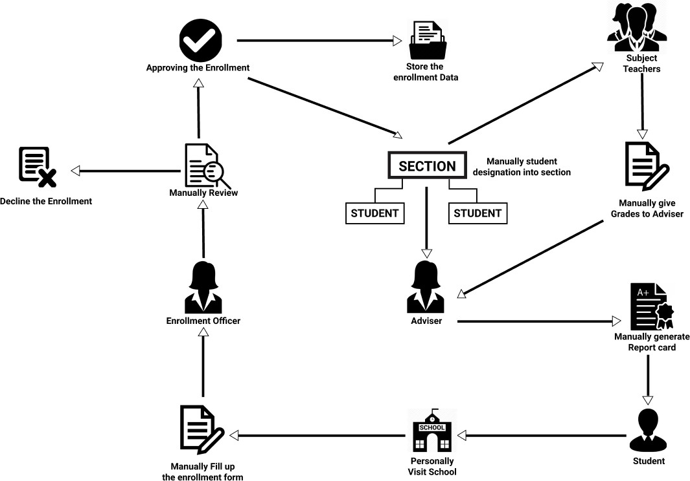

*Figure 1.* Current Conceptual Framework

Mantalongon National High School is currently adopting the traditional process of enrollment. This traditional flow allows the student to start the process through personally visiting the school during the enrollment period. As the enrollment starts, students are advised to line up for the admission form and manually fill out all the information asked like their personal background and some of their education history. After providing all the necessary details, the student

should again line up to the respective areas for each grade level and pass the form to the enrollment personnel. The enrollment personnel then continue the process through checking the forms one by one and validating all the information needed before the enrollment is to be approved. Students enrolled are then manually designated by the enrollment personnel to different sections. Enrollment process is then finished by storing all the enrollment papers in a cabinet to be kept as school’s records. Next is the grading of students. Each subject teacher provides a quarterly grade of the students to the adviser by writing it on a paper and the adviser manually generates a report card of the students.

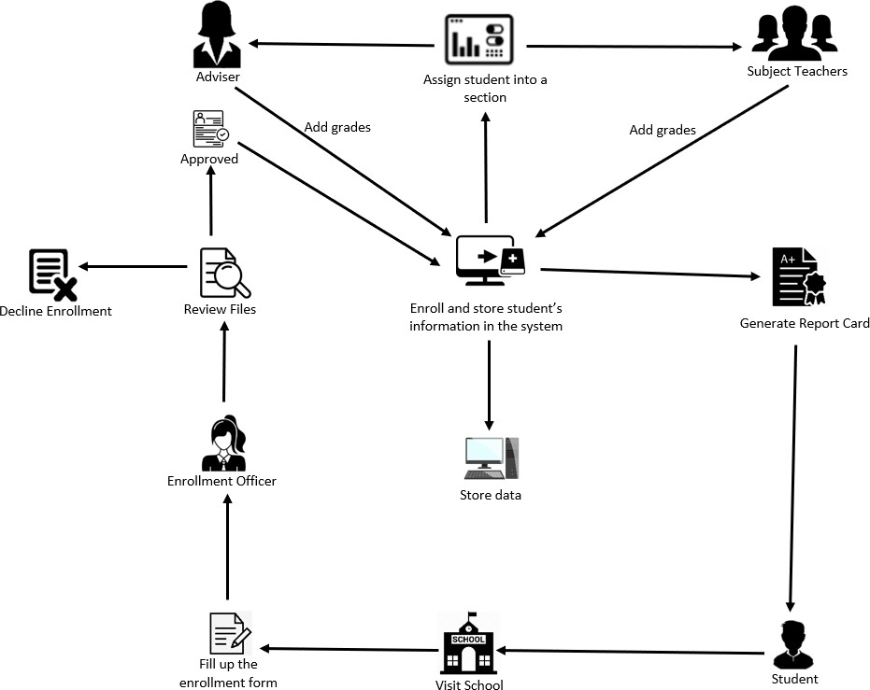

*Figure 2.* Proposed Enrollment Process for Mantalongon National High School

This is the process that the system is expected to do. After the student filled up the required information in the admission form, they will submit it to the enrollment officer then the enrollment officer will manually review the documents whether to approve or decline the enrollment.

Once the application is approved, the student will be enrolled and registered in the system and store the data for future purposes. After which, they will be designated into different sections using the system which have advisers and subject teachers. The adviser has the opportunity to access the information of the students.

At the end of the semester or quarter, the teachers (adviser and subject teachers) will give the grades to the students using the system and the system will generate the report cards of the students.

# Analysis and Design

To present the analysis and design of the Enrollment System for Mantalongon National High School, the developers used the Entity Relationship Diagram (ERD) and Use Case Diagram.

# Use Case Diagrams

The use case diagrams below show action that the system can perform in collaboration with different users.

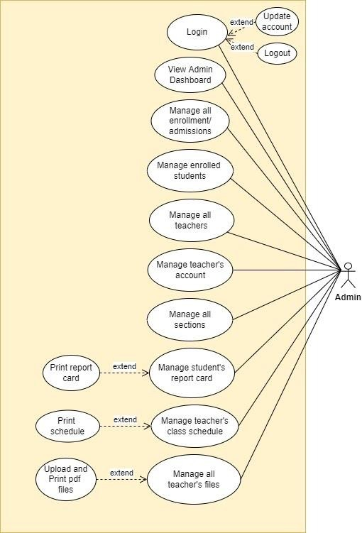

*Figure 3*. Use Case Diagram for Admin

This shows the functionalities of the administrator in the system. As an admin user, most of the functionalities are assigned and could be done by the personnel assigned.

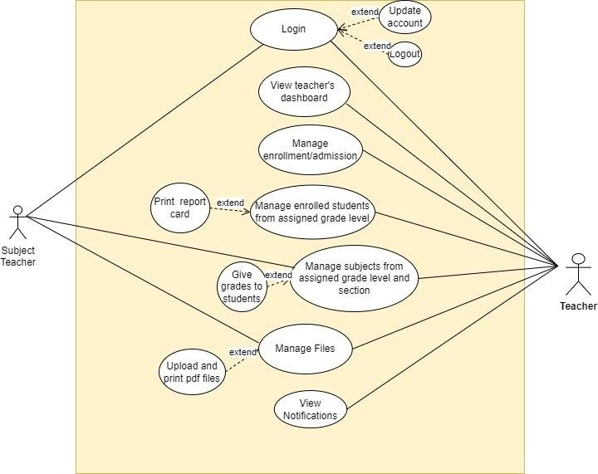

*Figure 4.* Use Case Diagram for Teacher and Subject Teacher

It presents the different actions that every end user could perform. The teacher or adviser will manage the admission, generate report cards, add subjects, add sections, manage students, upload and print pdf files, and view schedules. Thus, for the subject teacher, a limited action could be performed and is restricted to use some modules.

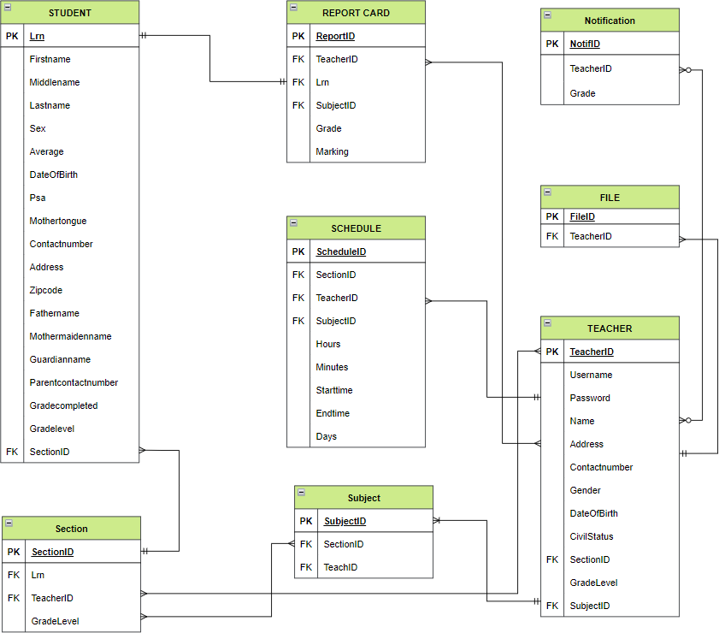

*Figure 5.* Entity Relationship Diagram of the Enrollment System for MNHS The figure illustrates how the database of the proposed system is

structured. It represents how the relationship of the data for the enrollment system

is connected and it serves a big role in creating an organized design for the backend models.

# Users and user details

* + - * The system has 3 different types of users which are the Administrator, Adviser and the Subject Teachers and the system requires user details for every user.

# Grading and notifications

* + - * Every time the subject teacher inputs the grade of a specific student it will automatically send a notification to the Adviser of the student.

# Files

* + - * Every user in the system can upload a file and print it as well.

# Grade level, sections, subjects, teachers and schedules

* + - * Grade level has many sections and subjects
      * Teachers have many schedules as well as the sections.

# Report card and Semester/Quarterly

* + - * Every time the teacher will input grades on the report card it will always base on what are the student are enrolled
  1. **Development Model**

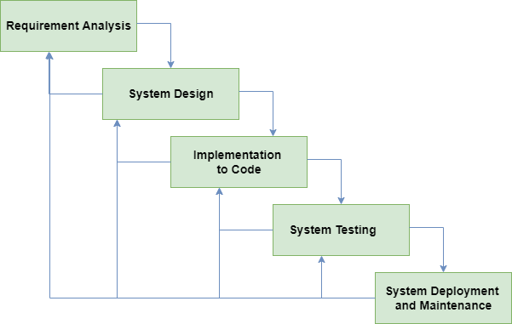

*Figure 6.* Enrollment System’s Development Model

This represents the modified waterfall model that will be used in developing the Enrollment System for MNHS. The developers choose to use this model because it provides a more efficient chance for the phases to be overlapped when there are changes and improvements. As the modified waterfall model gives the developers more flexibility, it also helps the development team create a faster output in a limited time. Modified waterfall model will also be a best fit for the development since there is already a fixed requirement for the system before the development starts.

# Development Approaches

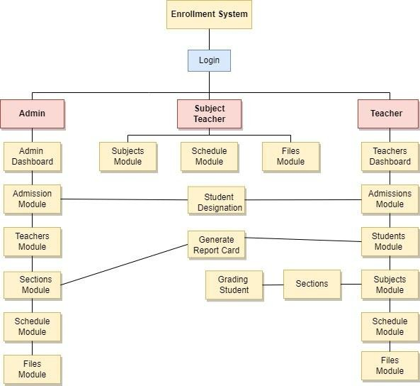

*Figure 7.* Top down Approach followed in system development

Figure 4.4.1 shows the top down developmental approach that is being followed in developing the system. The developers chose to use such an approach for the development because it allows breaking down the general concept to the smaller ones so that the development process would be easier to work out. The approach helps the proponents to identify what modules are to be done first as the smaller parts are already identified. The large modules of the admin like the dashboard, enrollment or admission module, teacher’s module, student’s module, sections module and schedule were broken down into submodules just like for the teacher’s section module, grades module and report card module. As for the teacher user side, the subject module is broken down into submodules namely the sections and under to sections, the grading of students is placed.

# Software Development Tools

The table shows the different software development tools that will be used in the development of the system.

Table 2.

Software Development Tools

|  |  |  |  |
| --- | --- | --- | --- |
| **Name** | **Version** | **Source** | **Use** |
| Visual Studio Code |  | https://code.visual studio.com/ | Software used for coding. |
| PHP Laravel |  | https://laravel.com / | Back-end framework |
| Bootstrap |  | https://getbootstrap.com/ | Front-end framework |
| MySQL |  | https://[www.mysql.com](http://www.mysql.com/) | Helps the communication of data |
| PhpMyAdmin |  | https://[www.phpmyadmin.net](http://www.phpmyadmin.net/) | Manipulate data in stored database |
| Javascript |  | https://[www.javascript.com/](http://www.javascript.com/) | Used as a client-side scripting language. |
| Github |  | https://github.com / | For Development Versioning |

|  |  |  |  |
| --- | --- | --- | --- |
| Postman | 5.5.5 | https://www.post man.com/ | For Development Testing |
| Diagrams.net |  | https://www.diagr ams.net/ | Used in making diagrams and flowcharts. |
| Figma |  | https://www.figma .com/ | A Web-based graphics editing and user interface design app |

# Project Management

Project management should be linked to planning and management to achieve the desired goals. It takes collaboration and communication between members to come up with bigger ideas. Discipline, respect each other, skills, and knowledge are essential for best results.

* + 1. **Schedule and Timeline**

The figures below show the planned schedule and timeline for the proponents to finish the system making it easier to track their progress.

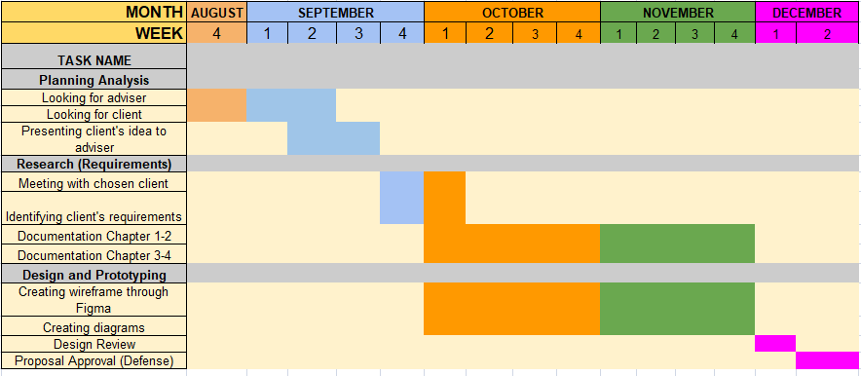

*Figure 8*. Gantt Chart for First Semester

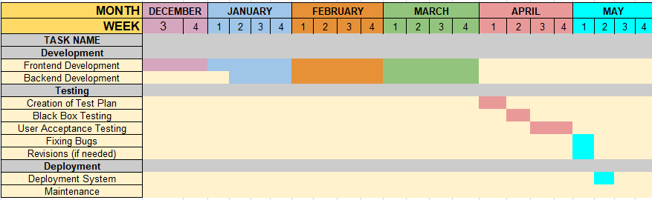

*Figure 9.* Gantt Chart for Second Semester

# Responsibilities

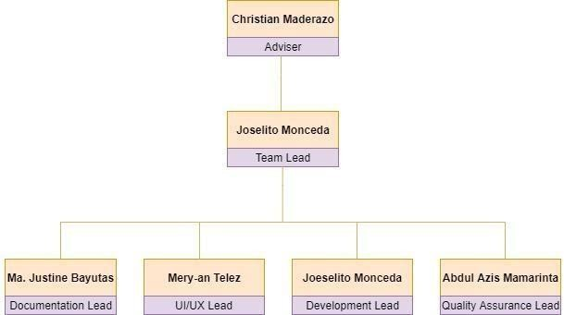

*Figure 8.* Team Structure

This shows how the task for the project is designated. It allows each member to lead in a specific area and be accountable for making the task well organized and be done on time as scheduled.

Table 4

Roles and Responsibilities

|  |  |  |  |  |
| --- | --- | --- | --- | --- |
| **Name of Developer** | **Ma Justine Bayutas** | **Abdul Azis Mamarinta** | **Joselito Monceda** | **Mery-an Telez**  **(*Project manager*)** |
| **Frontend** | Support | Support | Support | Lead |
| **Backend** | Support | Support | Lead | Support |
| **Documentations** | Lead | Support | Support | Support |
| **Testing and**  **Reviews** | Support | Lead | Support | Support |

# Budget and Cost Management

The table below shows the approximate cost of the development of the project.

Table 5

Estimated Budget and Cost

|  |  |  |  |  |
| --- | --- | --- | --- | --- |
| **Item** | **Quantity** | **Unit** | **Price Per Unit** | **Estimated Cost** |
| Laptop | 2 | pc | Php 20,000.00 | Php 40,000.00 |
| Computer Set | 2 | set | Php 25, 500.00 | Php 51,000.00 |
| Internet (WIFI) |  |  | Php 1, 299.00/month | Php 12, 990.00 |
| Electricity |  |  | Php 1000.00/month | Php 10,000.00 |
| Miscellaneous |  |  | Php 50.00/month | Php 500.00 |
| **Estimated Total Cost:** | | | | **Php 114, 490.00** |

# Verification, Validation and Testing

Testing the system is done by the developer every after one phase to make sure that it functions well according to the requirements asked. Thus, systems should always have testers after completing all the modules to surface failures and to integrate all its requirements if it meets the criteria. Black box testing and user

acceptance testing was used as testing techniques for the enrollment system that is performed after the development.

* Black-box testing is a software testing technique that focuses on software functional analysis. It was developed as a tool to evaluate customer requirements, specifications, and strategies of high-level design. Also, select some conditions to check for the correct output response of the actual and the incorrect input and code execution conditions. This can be done after the latest features have been developed. Therefore, for our black-box testing, we will let 10 software testers test our proposed system.
* User acceptance testing (UAT) also known as beta or end-user testing is the final stage of the entire software development life cycle. This is the place where real users test the software to see if they can perform the required task designed in the real world as well as perform requirements for development. UAT tests compliance with client requirements. Through our calculation, this testing process involves 33 testers for advisory teachers, 18 testers for non-advisory teachers and 5 testers for admin.

# Bibliography

**Web Articles**

Cuebas, R. B., et. al*. Enrollment System for General Emilio Aguinaldo National High School. Retrieved from: https://*[*www.academia.edu/5167264/Enrollmentsystem_DOC*](http://www.academia.edu/5167264/Enrollmentsystem_DOC)

Abad, C. et. al. *Computerized Registration Form for Fort Bonifacio High*

*School. Retrieved from:*

*https://*[*www.academia.edu/12481788/Computerized_Registration_F*](http://www.academia.edu/12481788/Computerized_Registration_F) *orm_f %20or_Fort_Bonifacio_High_School*

Sentina, F. & Luna, N. (2009). *Automated Enrollment System of Palompon Institute of Technology- Tabango Campus, MRVNPC, Tabango Leyte. Retrieved from:*

*https://*[*www.academia.edu/12645313/AUTOMATED_ENROLMENT*](http://www.academia.edu/12645313/AUTOMATED_ENROLMENT)

*_SYSTEM_OF_PALOMPON_INSTITUTE_OF_TECHNOLOGY_TA BANGO_CAMPUS_MRVN PC_TABANGO_LEYTE*

Kong, K. K., Chan, Y. M., Law, Y. Y. & Leung, S. H.. (2001)*. Online Enrollment and Administration System, Real World Database Development. Retrieved from:*

*https://home.cse.ust.hk/~fred/FYP/DBDevelopment/Guidelines/sam ple-reports/db proposal.pdf*

De Guzman, M., Diaz, L. M., & Gonzaga, M. A. (2017).

*COMPUTERIZE ENROLLMENT SYSTEM OF SAINT MARY’S*

*ACADEMY OF ROSARIO. Retrieved from: https://*[*www.academia.edu/31749481/SMA_THESIS*](http://www.academia.edu/31749481/SMA_THESIS)

KUPDF.net (2016, July 5). *thesis for enrollment system ACLC. Retrieved from:*

*https://kupdf.net/download/thesis-for-enrollment-system*

Agustin, M. K. (2017, May 17)*. Thesisbook Documentation. Release*

*0.0.1. Retrieved from:* [*https://readthedocs.org/projects/thesisbook/downloads/pdf/latest/*](https://readthedocs.org/projects/thesisbook/downloads/pdf/latest/)

PaperAp.com (2018). *Computer-Aided Enrollment System Study. Retrieved from:*

*https://paperap.com/computer-aided-enrollment-system-study/*

SCHOOLMINT COLLECTIVE. (2016, June 7). *Automating the School Enrollment Process – in the Name of Efficiency. Retrieved from:*

[*https://www.schoolmint.com/why-k-12-schools-should-manage-*](https://www.schoolmint.com/why-k-12-schools-should-manage-student)[*student*](https://www.schoolmint.com/why-k-12-schools-should-manage-student) *enrollment-*

*online/#:~:text=Benefits%20of%20Online%20Enrollment%20Mana gement,into%2 0a%20registry%20by%20hand*

PhDessay.com.(2017, Apr 18). *Computerized Enrollment System. Retrieved from. https://phdessay.com/computerized- enrollements-system/*

Palit-ang, A. ( 2014 ). *Computerized Enrollment System for Cieverose College. Retrieved from.* [*https://www.academia.edu/36243740/Gabriel*](https://www.academia.edu/36243740/Gabriel)

[Bryan lalu (2014)](https://prezi.com/user/jglmaemycffp/) Computerized Enrollment System of Saint Joseph School of Candaba. Retrieved Oct 10 2014. Retrieved from. <https://prezi.com/d1ha3v1uaxl3/abstract/>

Mababuhay (2021) Database Management System, Enrollment, Computerized Enrollment System. Retrieved from. <https://www.coursehero.com/file/19660823/49014916-Thesis-123/>

S[hymiya ka](https://independent.academia.edu/shymiyaka?swp=tc-au-7860081) (2021) College enrollment System. Retrieved from: <https://www.academia.edu/7860081/College_Enrollment_System>

Miranda (2019) :Aplaya National High School Enrollment System with Descriptive Analysis. Retrieve on March- April 2019. [https://www.proquest.com/openview/ea9cbff8bb22f163bc21900f51](https://www.proquest.com/openview/ea9cbff8bb22f163bc21900f51b107c7/1?pq-origsite=gscholar&cbl=1606379) [b107c7/1?pq-origsite=gscholar&cbl=1606379](https://www.proquest.com/openview/ea9cbff8bb22f163bc21900f51b107c7/1?pq-origsite=gscholar&cbl=1606379)

Wanwika (2019) The Development of the Free Enrollment System, undergraduate of Suan Sunandha Rajabhat University. Retrieved from:[http://www.ijbts-journal.com/images/main_1366796758/V19-](http://www.ijbts-journal.com/images/main_1366796758/V19-07%20Wanwika%20Sattaworn.pdf) [07%20Wanwika%20Sattaworn.pdf](http://www.ijbts-journal.com/images/main_1366796758/V19-07%20Wanwika%20Sattaworn.pdf)

Napit (2021) School Computerized system. Retrieved from: [https://www.inettutor.com/source-code/enrollment-system-complete-](https://www.inettutor.com/source-code/enrollment-system-complete-capstone-documentation/) [capstone-documentation/](https://www.inettutor.com/source-code/enrollment-system-complete-capstone-documentation/)

Clever (2021) Web Based College Admission System. Retrieved from: [https://www.academia.edu/37038602/Web_Based_College_Admiss](https://www.academia.edu/37038602/Web_Based_College_Admission_System) [ion_System](https://www.academia.edu/37038602/Web_Based_College_Admission_System)

Carbonell (2015) :College Enrollment System. Retrieve on March 18, 2015: <https://prezi.com/t2pjtpl1jxqn/college-enrollment-system/>

Pascual Luna III (2009): Automated Enrollment System of Palompon Institute of Technology -Tabango Campus , MRVNPC ,Tabango, Leyte. Retrieved from. [https://www.academia.edu/12645313/AUTOMATED_ENROLMENT](https://www.academia.edu/12645313/AUTOMATED_ENROLMENT_SYSTEM_OF_PALOMPON_INSTITUTE_OF_TECHNOLOGY_TABANGO_CAMPUS_MRVNPC_TABANGO_LEYTE)

[_SYSTEM_OF_PALOMPON_INSTITUTE_OF_TECHNOLOGY_TA](https://www.academia.edu/12645313/AUTOMATED_ENROLMENT_SYSTEM_OF_PALOMPON_INSTITUTE_OF_TECHNOLOGY_TABANGO_CAMPUS_MRVNPC_TABANGO_LEYTE) [BANGO_CAMPUS_MRVNPC_TABANGO_LEYTE](https://www.academia.edu/12645313/AUTOMATED_ENROLMENT_SYSTEM_OF_PALOMPON_INSTITUTE_OF_TECHNOLOGY_TABANGO_CAMPUS_MRVNPC_TABANGO_LEYTE)

Panganiban (2020) An Assessment By The Students Regarding Enrolment System Of Ama Computer College Santiago City Campus. Retrieved from. [http://www.ijstr.org/final-print/feb2020/An-Assessment-By-](http://www.ijstr.org/final-print/feb2020/An-Assessment-By-The-Students-Regarding-Enrolment-System-Of-Ama-Computer-College-Santiago-City-Campus.pdf) [The-Students-Regarding-Enrolment-System-Of-Ama-Computer-](http://www.ijstr.org/final-print/feb2020/An-Assessment-By-The-Students-Regarding-Enrolment-System-Of-Ama-Computer-College-Santiago-City-Campus.pdf) [College-Santiago-City-Campus.pdf](http://www.ijstr.org/final-print/feb2020/An-Assessment-By-The-Students-Regarding-Enrolment-System-Of-Ama-Computer-College-Santiago-City-Campus.pdf)

Bacala & Reaño (2009) Computerized Enrollment for St. Jude Parish School. Retrieved from. [https://pdfcoffee.com/computerized-](https://pdfcoffee.com/computerized-enrollment-pdf-free.html) [enrollment-pdf-free.html](https://pdfcoffee.com/computerized-enrollment-pdf-free.html)

Eugerio (2021) Computerized Enrollment | Databases – Scribd. Retrieved from: [https://www.scribd.com/doc/298506224/Computerized-](https://www.scribd.com/doc/298506224/Computerized-Enrollment) [Enrollment](https://www.scribd.com/doc/298506224/Computerized-Enrollment)

GraduateWay (2016): Computerized Enrollment System Example. Retrieved on October 2 ,2016. <https://graduateway.com/computerized-enrollment-system/>

Computerized System for DCNHS shall result to a significant increase in the: Course Hero. Retrieved from. [https://www.coursehero.com/file/p3a30sv/computerized-system-for-](https://www.coursehero.com/file/p3a30sv/computerized-system-for-DCNHS-shall-result-to-a-significant-increase-in-the/) [DCNHS-shall-result-to-a-significant-increase-in-the/](https://www.coursehero.com/file/p3a30sv/computerized-system-for-DCNHS-shall-result-to-a-significant-increase-in-the/)

Enrollment System Related Literature and Studies. Retrieved from. [https://www.bartleby.com/essay/Enrollment-System-Related-](https://www.bartleby.com/essay/Enrollment-System-Related-Literature-and-Studies-P3B4VAS8CKDQ) [Literature-and-Studies-P3B4VAS8CKDQ](https://www.bartleby.com/essay/Enrollment-System-Related-Literature-and-Studies-P3B4VAS8CKDQ) -

Napit (2021): Enrollment System Review of Related Literature. Retrieved from. [https://www.inettutor.com/source-code/enrolment-system-](https://www.inettutor.com/source-code/enrolment-system-review-of-related-literature/) [review-of-related-literature/](https://www.inettutor.com/source-code/enrolment-system-review-of-related-literature/)

Course Hero (2021). Local and Foreign Literature. Review of Related Literature and Studies This chapter: Course Hero. Retrieved from. [https://www.coursehero.com/file/70031128/Chapter2-Local-and-](https://www.coursehero.com/file/70031128/Chapter2-Local-and-Foreign-Literaturedocx/) [Foreign-Literaturedocx/](https://www.coursehero.com/file/70031128/Chapter2-Local-and-Foreign-Literaturedocx/)

Sigmabrown (2021). Enrollment System (ES) 4.7. Department of Veterans Affairs. Office of Information and Technology (OI&T) Product Development. Retrieved September 30, 2017.

[https://sigmabrown725.weebly.com/sample-user-manual-for-](https://sigmabrown725.weebly.com/sample-user-manual-for-enrollment-system.html) [enrollment-system.html](https://sigmabrown725.weebly.com/sample-user-manual-for-enrollment-system.html)

Perez (2021): Chapter II. REVIEW OF RELATED LITERATURE AND STUDIES.

[https://www.academia.edu/30985613/Chapter_II_REVIEW_OF_RE](https://www.academia.edu/30985613/Chapter_II_REVIEW_OF_RELATED_LITERATURE_AND_STUDIES) [LATED_LITERATURE_AND_STUDIES](https://www.academia.edu/30985613/Chapter_II_REVIEW_OF_RELATED_LITERATURE_AND_STUDIES)

Review related literature and studies about record keeping system. Retrieved from. [http://cyviwexovorexyq.fresh-air-](http://cyviwexovorexyq.fresh-air-purifiers.com/review-related-literature-and-studies-about-record-keeping-system-6941de6036.html) [purifiers.com/review-related-literature-and-studies-about-record-](http://cyviwexovorexyq.fresh-air-purifiers.com/review-related-literature-and-studies-about-record-keeping-system-6941de6036.html) [keeping-system-6941de6036.html](http://cyviwexovorexyq.fresh-air-purifiers.com/review-related-literature-and-studies-about-record-keeping-system-6941de6036.html)

Enrollment Management in Higher Education: From Theory to Practice. Retrieved from.

https://digital.library.unt.edu/ark:/67531/metadc2651/m1/23/

V. Allen Clark, B.S., M.S. - UNT Digital Library. Retrieved from. https://digital.library.unt.edu/ark:/67531/metadc2651/m2/1/high_res

_d/Dissertation.pdf

Sample User Manual for Enrollment System. Retrieved from. <https://sample-user-manual-for-enrollment-system-526.peatix.com/>

Lopez (2005) Dagupan City National High School DCNHS Enrollment system. Course Hero. Retrieved from. [https://www.coursehero.com/file/p2carhvh/Dagupan-City-National-](https://www.coursehero.com/file/p2carhvh/Dagupan-City-National-High-School-DCNHS-Enrollment-system-According-to-Lopez/) [High-School-DCNHS-Enrollment-system-According-to-Lopez/](https://www.coursehero.com/file/p2carhvh/Dagupan-City-National-High-School-DCNHS-Enrollment-system-According-to-Lopez/)

Conde (2007) Chapter 2: Review of Related Literature and studies. Retrieved from.

<http://thesisbook.readthedocs.io/en/latest/Chapter%20II.html>

Garcia (2002) Computerized Enrollment System. Retrieved from. <https://graduateway.com/computerized-enrollment-system/>

Valina et.al (2009), Student Record System. Retrieved from. <https://essaylead.com/student-record-system/>

Soria (2006), Computerized Enrollment System. Retrieved from. <https://www.academia.edu/31316821/Merl>

Cabang et al. (2003) Network-based student Permanent Record keeping and Enrollment System of Balian National High School. Retrieved from. [https://www.coursehero.com/file/p7ql8ji/Saayo-etal-2008-](https://www.coursehero.com/file/p7ql8ji/Saayo-etal-2008-developed-the-system-Network-based-automated-Enrollment-and/) [developed-the-system-Network-based-automated-Enrollment-and/](https://www.coursehero.com/file/p7ql8ji/Saayo-etal-2008-developed-the-system-Network-based-automated-Enrollment-and/)

Velasco (2002), Online Integrated Enrollment System. Retrieved from. [https://www.scribd.com/document/436785490/Online-Integrated-](https://www.scribd.com/document/436785490/Online-Integrated-Enrollment-System-docx) [Enrollment-System-docx](https://www.scribd.com/document/436785490/Online-Integrated-Enrollment-System-docx)

Cura et al. (2004), Computerized Enrollment System. Retrieved from. <https://graduateway.com/computerized-enrollment-system/>

Torres et al. (2002) Computer Aided Examination System. Retrieved from. https://blablawriting.net/computer-aided-examination-system- essay

Alcaira (1999) Enrollment System . Retrieved from. [https://www.academia.edu/7761467/Chapter1_2_100711202027_p](https://www.academia.edu/7761467/Chapter1_2_100711202027_phpapp02) [hpapp02](https://www.academia.edu/7761467/Chapter1_2_100711202027_phpapp02)

Aravia et al. (2002) Computerized Enrollment System. Retrieved from. <https://graduateway.com/computerized-enrollment-system/>

Garnace (1999) Employee Management System. Retrieved from. <https://www.termpaperwarehouse.com/essay-on/Chapter-Ii/425489>

Gumitao (2001), Sample User Manual for Enrollment System. Retrieved from. [https://sigmabrown725.weebly.com/sample-user-manual-for-](https://sigmabrown725.weebly.com/sample-user-manual-for-enrollment-system.html) [enrollment-system.html](https://sigmabrown725.weebly.com/sample-user-manual-for-enrollment-system.html)

Revalla (2005) Computerized Enrollment System. Retrieved from. <https://graduateway.com/computerized-enrollment-system/>

Encila (1999) Computerized Enrollment System. Retrieved from. [https://www.coursehero.com/file/48838023/Chapter-II-REVIEW-OF-](https://www.coursehero.com/file/48838023/Chapter-II-REVIEW-OF-RELATED-LITERATURE-AND-STUDIES-samplepdf/) [RELATED-LITERATURE-AND-STUDIES-samplepdf/](https://www.coursehero.com/file/48838023/Chapter-II-REVIEW-OF-RELATED-LITERATURE-AND-STUDIES-samplepdf/)

Kampitan (2000), Review of Related Literature and Studies. Retrieved from. [https://www.scribd.com/document/434758397/Computerized-](https://www.scribd.com/document/434758397/Computerized-Enrollment-System) [Enrollment-System](https://www.scribd.com/document/434758397/Computerized-Enrollment-System)

# APPENDIX A TRANSMITTAL LETTER

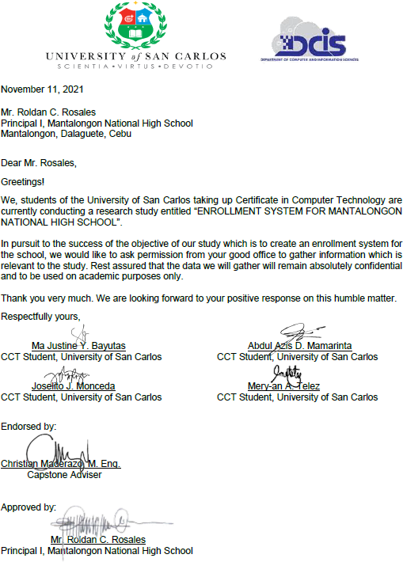

**APPENDIX B INTERVIEW GUIDE**

**Interview Guide**

* + 1. What problem does the client want to solve?
    2. How can the system solve the problem stated in the first question?
    3. How many users does this system need to have and who are these users?
    4. What could the users do in the system?
    5. What are the major modules that this system needs to have?

# APPENDIX C QUESTIONNAIRE

|  |  |  |  |  |  |  |
| --- | --- | --- | --- | --- | --- | --- |
| **Criteria** | **Description** | **Rating (1 -**  **Lowest / 5 Highest)** | | | | |
|  |  | **1** | **2** | **3** | **4** | **5** |
| **1. Functionality** |  | | | | | |
| 1.1 Accuracy | How does the system adequately meet its objectives? |  |  |  |  |  |
| 1.2 Security | How protected is the system and its data contents from unauthorized access? |  |  |  |  |  |
| **2. Reliability** |  | | | | | |
| 2.1 Data Validity | Does the system check and validate user input to avoid erroneous data entry? |  |  |  |  |  |
| **3. Usability** |  | | | | | |
| 3.1 Learnability | Is the system user friendly? |  |  |  |  |  |
| 3.2 Attractiveness ss | Is the overall user interface visually pleasing |  |  |  |  |  |
| **4. Efficiency** |  | | | | | |
| 4.1 Ease of Start-up | How easily is the system started up? |  |  |  |  |  |
| 4.2 Resources Utilization | Does the system require minimal hardware services |  |  |  |  |  |

|  |  |  |  |  |  |  |
| --- | --- | --- | --- | --- | --- | --- |
| 4.3 Time behavior | How quickly does the system accomplish specific actions |  |  |  |  |  |
| **5. Maintainability** |  | | | | | |
| 5.1 Installability | How easily system does the system is being access in browser |  |  |  |  |  |
| 5.2 Testability | Can the system be tested and verified using test/sample data? |  |  |  |  |  |
| **6. User Manual** |  | | | | | |
| 6.1  Understandability | Does the user manual provide clear and concise instructions on how to operate the software? |  |  |  |  |  |
| 6.2 Visual References | Does the user manual provide actual screenshots showing how to operate the software |  |  |  |  |  |

**APPENDIX D**

**SOFTWARE REQUIREMENTS SPECIFICATION**

**ENROLLMENT SYSTEM FOR MANTALONGON NATIONAL HIGH SCHOOL - DALAGUETE, CEBU**

A complete Software Requirements Specifications Version 1.0

# Client Name:

Mr. Roldan C. Rosales

# Proponent:

Ma Justine Y. Bayutas Abdul Azis D. Mamarinta

Joselito J. Monceda Mery-an A. Telez

# Introduction/Rationale of the Study

The period that the technology arises is known to be the new era especially in the field of education. Technology brought a wide variety of opportunities in building lighter loads of educators and learners (Harris et. al., 2016). As mentioned by Miranda (2019), advancement of technology is taking its step one day at a time to provide solutions for the limitations of the human race. These innovations are made by people for the people to help in making everyday jobs easier. Information systems were being upgraded to handle more complex and large data; one of them is the Enrollment System. As the school increases in its enrollees every year, the harder it becomes to deal with, particularly in public academic institutions wherein the population of the students is massive. Improvement in technologies and learning never ends, as well as the educational system (Panganiban,2020). It revolutionized the field of education therefore its importance cannot be ignored by schools for it made the process of teaching learning all the more efficient (Cuebas; Kumar, 2021). According to Raja & Nagasubramani (2018), there are four aspects of education that technology has positively affected: technology as part of curriculum, as an instructional delivery system, as means of providing instruction and also as a tool to enhance the entire learning process.

Considering the tedious task of filling out the admission form and the inaccuracies of information provided by the students, the traditional enrollment process is indeed taking time (KUPDF.net, 2016). These factors cause enrollment delays, which is disadvantageous to the enrollment personnel and as well as the students (Agustin, 2017). A manual enrollment system also resulted in a lot of challenges in handling school transactions resulting in more serious problems like unreliable records of the scholars and data losses (PaperAp.com, 2018; Cayabyab, 2016). Enrollment-related documents that need to be tracked and maintained during and after the enrollment process is a plus to the workload (SCHOOLMINT COLLECTIVE,

2016). The traditional enrollment process is known to be a very stressful time for school personnel and students considering that yearly students of schools are sometimes unpredictably increasing (PhDessay.com, 2017). With this, the implementation of an offline enrollment system is considered because such a system has to be capable of handling the surge of network connections from the student’s population during the admission period by just a use of a computer device and a database (Darunday, 2016).

With this, the proponents proposed an enrollment system for Mantalongon National High School which will help overcome the school’s need for less hassle, less time consuming and even more productive enrollment process. The implementation of the system in the school will also lessen the school personnel’s effort in dividing the students into different sections as it will automate the students’ section designation. Thus, it will also provide flexibility because the admin could always have the rights to navigate the different modules of the system like adding a new section of a specific grade level, adding a new teacher assigned in a section, and most especially view schedules and print the files being uploaded by the teachers. The teachers have an individual account wherein they are the one who will enroll and store the student’s information in the system and assign the students to their designated sections. At the end of every quarter or semester, the teachers can give their grades to the students using the system and the system will automatically generate the report cards of every student.

# System Description

This Enrollment System for Mantalongon National High School is a web application that reduces the load of the teachers.

The system aims to develop a fast, accurate and reliable computer-based enrollment system for administration, and facilitate and secure students’ records. The system also includes features such as section management, printing their

schedules of specific sections they handled and give grades and print the report cards of the students which makes the process even more efficient.

The system will be developed using Laravel as the framework for the backend side and blade for the UX/UI. The system will also use localhost MySQL for its database.

# Design Model



*Figure 2.* Proposed Enrollment Process for Mantalongon National High School This is the process that the system is expected to do. After the student filled

up the required information in the admission form, they will submit it to the

enrollment officer then the enrollment officer will manually review the documents whether to approve or decline the enrollment.

Once the application is approved, the student will be enrolled and registered in the system and store the data for future purposes. After which, they will be designated into different sections using the system which have advisers and subject teachers. The adviser has the opportunity to access the information of the students.

At the end of the semester or quarter, the teachers (adviser and subject teachers) will give the grades to the students using the system and the system will generate the report cards of the students.

**System Flow/Development Process**

The system consists of 4 major modules that need to be developed: Enrollment/ Admission, Section Designation, Teacher Scheduling and Report Card generation Module.First is the development of the enrollment/admission which includes the admission form where the students’ information should be entered. Second is the section designation module that includes adding a section in a grade level where the student should belong. Third is the teacher scheduling module that includes adding teacher’s schedules which can also be viewed by the teachers. And lastly, is the report card generation where all the inputted grades of advisers and subject teachers will be automatically displayed on the report card template and can be printed. The additional modules are adding teachers assigned to a section,notification settings where all the grades submission of subject teachers will be notified to the adviser teacher, a profile settings module that allow all users to update the password of their account, files module where all the users can upload pdf files and also can print and grading module where the adviser teacher and subject teacher can submit grade to a student every quarter/semester.

**Use Case Diagram**

*Figure 3.* Use Case Diagram for Admin

This shows the functionalities of the administrator in the system. As an admin user, most of the functionalities are assigned and could be done by the personnel assigned.



*Figure 4.* Use Case Diagram for Teacher and Subject Teacher

It presents the different actions that every end user could perform. The teacher or adviser will manage the admission, generate report cards, add subjects, add sections, manage students, upload and print pdf files, and view schedules. Thus, for the subject teacher, a limited action could be performed and is restricted to use some modules.

# Wireframe of the Enrollment System for Mantalongon National High School - Dalaguete, Cebu

The Admin user account of the online enrollment system enables the assigned personnel to manipulate all modules of the system including the login module, profile settings, dashboard module, enrollment module, teachers’ module, sections module, schedule module and files’ module.

**Admin User**

**Landing Page**

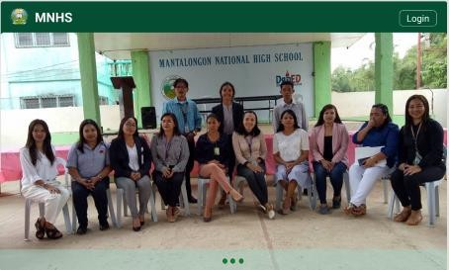

1. Login button - click the button, it redirects to the login page where teacher credentials will be asked.

# Login Module

To login as super administrator in the system, the enrollment officer should input the default username (Administrator) and password (Password) and click the login button.

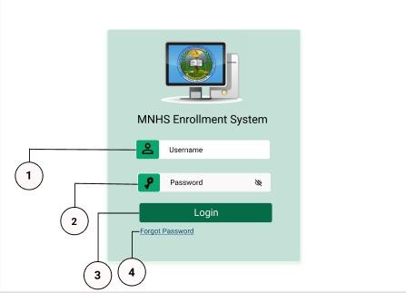

1. Username input field - requires “Administrator” as a default input.
2. Password input field - requires a minimum length of 8 characters and maximum of 16 characters

- should include lowercase and uppercase letters, a number and a special character.

1. Login button - Click to login to the system and be redirected to the admin dashboard.
2. Forgot password - Click the forgot password link and you will be asked to input your mobile number for your account recovery.

# Admin Profile Setting

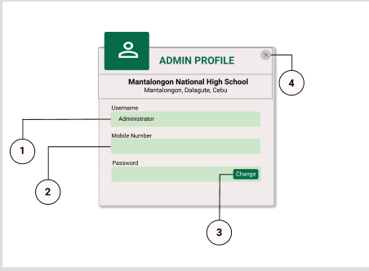

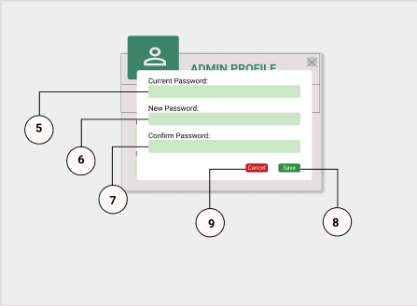

* 1. Username - is disabled and does not require any changes.
  2. Mobile number – requires the admin to input a mobile number for forgot password purposes.
  3. Change button - clicks the button, it appears a modal to change password.
  4. Close icon - click the icon and it will close the modal window and redirects you to the admin dashboard
  5. Current password input field - requires the admin to input the default password.
  6. New password input field - requires the admin to input a strong password (minimum length of 8 characters and maximum of 16 characters, include lowercase and uppercase letters, a number and a special character).
  7. Confirm password input field - requires the admin to input the same value with the new password field.
  8. Save button - click the button and it will redirect the admin to the admin dashboard.
  9. Cancel button - click the button and it will redirect to the admin dashboard.

# Admin Dashboard

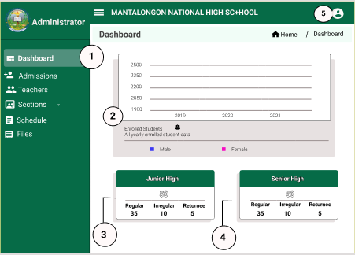

1. Dashboard Tab - enables the admin to see the dashboard content.
2. Enrollment graph - shows yearly reports of female and male students.
3. Junior High tab - shows the total number of junior high students enrolled and also shows the number of students in designated type.
4. Senior High tab - shows the total number of senior high students enrolled and also shows the number of students in designated type.
5. User icon - click the icon and it will redirect to the profile settings module.

# Admission Module

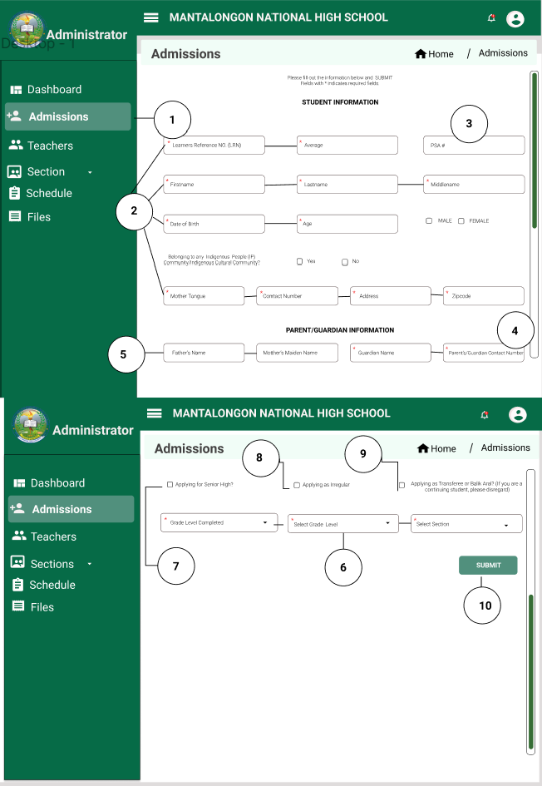

1. Admissions Tab - clicking the tab routes to the page displaying the admission form.
2. Students' information input fields - LRN, average, first name, last name, middle name, date of birth, age, gender, mother tongue, contact number, address, and zip code input fields are required.
3. PSA number input field - it is an optional input field.
4. Parents information input fields - guardian name and guardian contact number are required.
5. Father’s name and Mother’s Maiden name input fields - these two are optional input fields.
6. Grade level completed, Select Grade level and Select Section input fields - these are required input fields.
7. Applying for Senior High box- click the box and it displays all the input fields for senior high students.
8. Apply as Irregular box - click the box and it displays all the input fields for irregular students.
9. Applying for Transferee or Balik Aral box - click the box and it displays all the input fields for irregular students.
10. Submit button - click the button and it saves all the data in the database.

**Teachers Module**

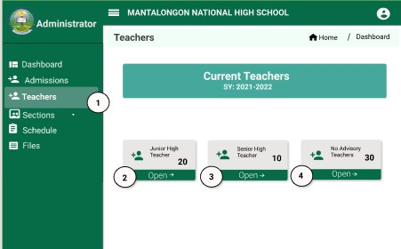

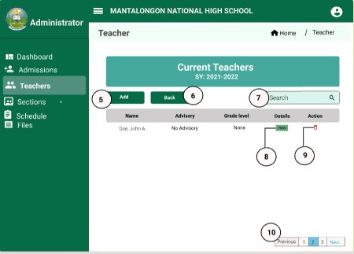

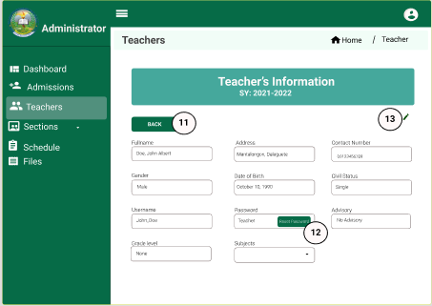

1. Teachers tab - clicking the tab routes to the three cards showing the total number of junior, senior and no advisory teachers.
2. Junior High Teacher card - shows the total number of junior high teachers and click the button and it routes to a table displaying the teacher’s details.
3. Senior High Teacher card - shows the total number of senior high teachers and click and it routes to a table displaying teacher’s detail.
4. Add button - clicks and it routes to the registration page where teacher’s information is asked.
5. Back button - clicks back to the first page.
6. Search input field - it searches the teachers’ data.
7. View button - clicks and it routes to display teacher’s information.
8. Trashcan icon - clicks and it deletes teacher.
9. Pagination button - clicks either previous or next and it displays another list of teachers.
10. Back button - click and go back to the list of teachers.
11. Reset Password button - click and it asks to input a new password.
12. Edit icon - click and input fields become editable.
13. Submit button - clicks and it saves the information and redirects to a list of teachers.
14. Back button - clicks and it goes back to the list of teachers.

# Sections Module

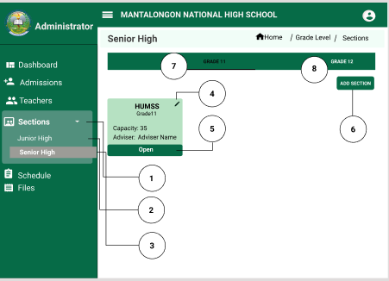

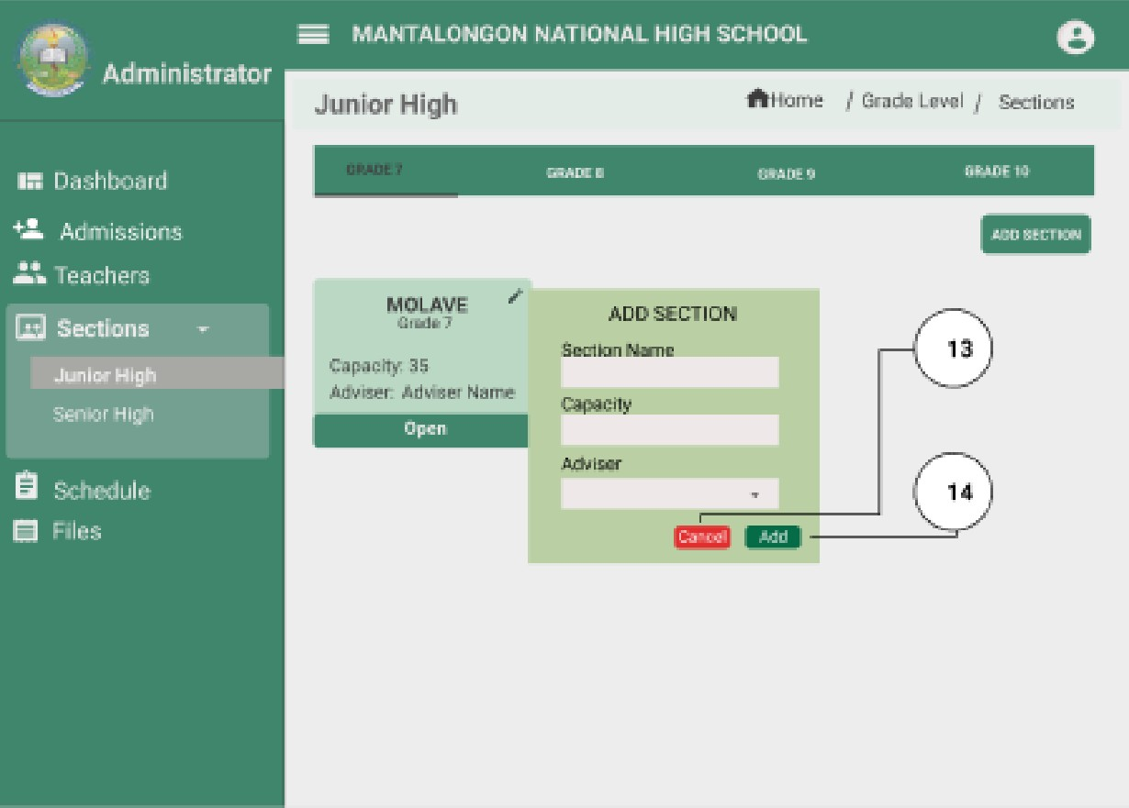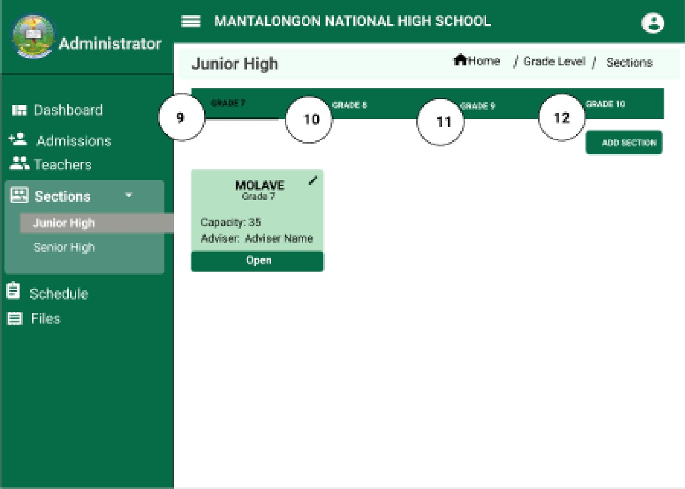

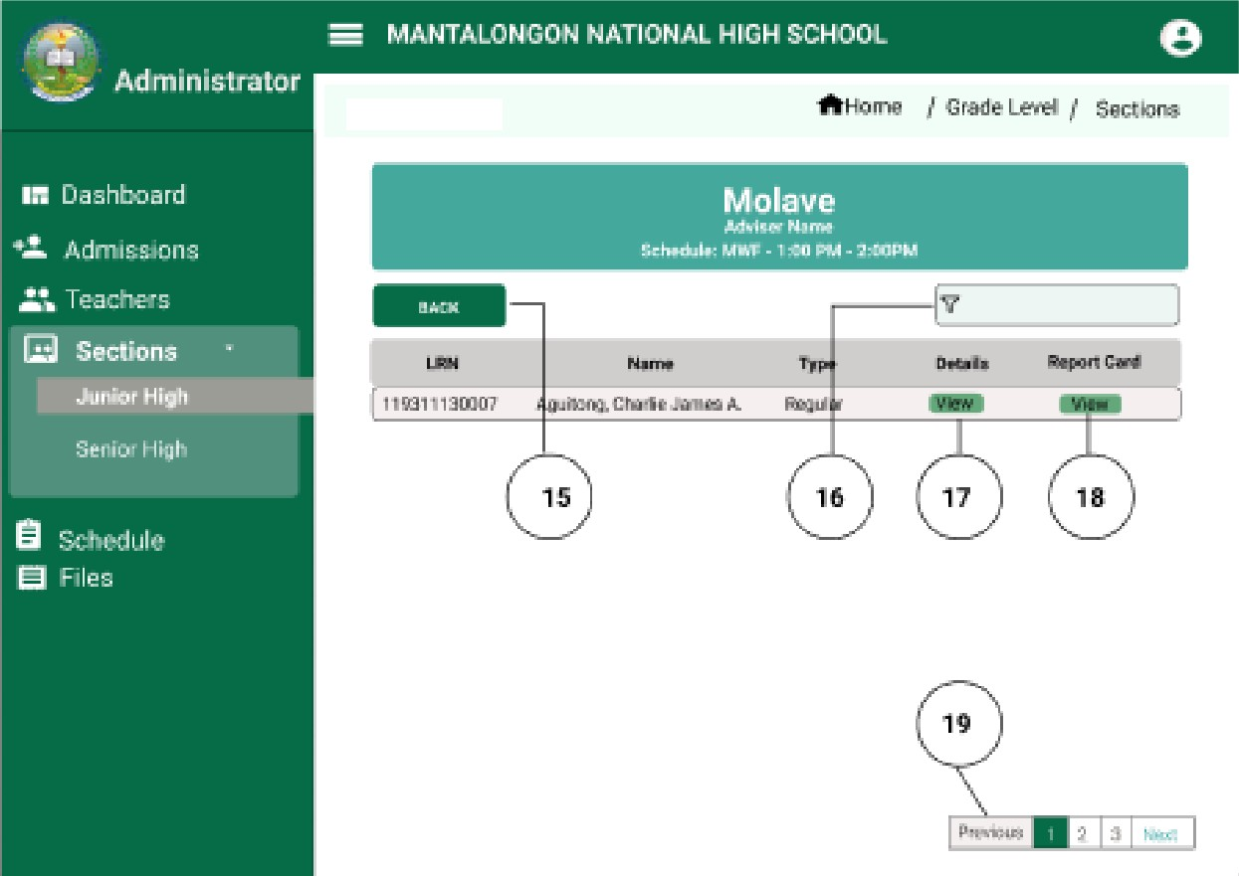

Jiailor High

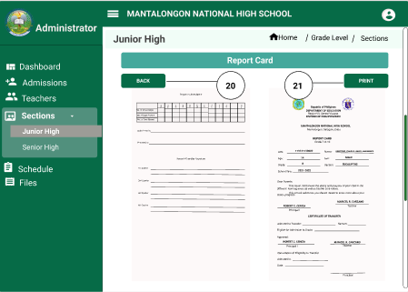

1. Sections tab - by clicking the sections tab, it will display a dropdown of Junior high and Senior high sections.
2. Junior high submenu- click the submenu and it will display another tab with the corresponding junior high-grade levels.
3. Senior high submenu- click the submenu and it will display another tab with the corresponding senior high grade levels.
4. Edit icon - clicks and the information display on the card become editable.
5. Open button - click the button and it routes to a list of students with details and a report card.
6. Add section button - click the button and it will ask to input a new section in the grade level selected.
7. Grade 11 tab - click the tab and it will display all the grade 11 sections.
8. Grade 12 tab - click the tab and it will display all the grade 12 sections.
9. Grade 7 tab - click the tab and it will display all the grade 7 sections.
10. Grade 8 tab - click the tab and it will display all the grade 8 sections.
11. Grade 9 tab - click the tab and it will display all the grade 9 sections.
12. Grade 10 tab - click the tab and it will display all the grade 10 sections.
13. Cancel button - click the button and it routes to the section tab.
14. Save button - click the button and it saves the information inputted and routes to the section tab.
15. Back button - click the button and it goes back to the sections tab.
16. Filter input field - it finds the students data easily.
17. View button for details - click the button and it displays the information of the student.
18. View button for report card - click the button and it displays the report card of the student.
19. Pagination button - click either the previous or next and it displays another list of student’s data.
20. Back button - click the button and it routes to the student's list.
21. Print button - click the button and it prints the report card.

# Schedule Module

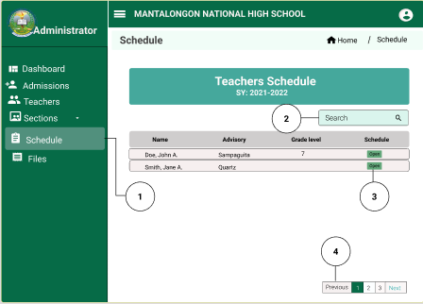

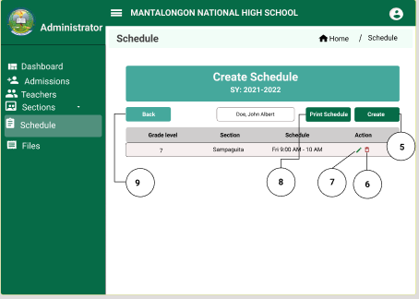

1. Schedule tab - by clicking the schedule tab, it will display a table of teachers.
2. Search field - it finds the teacher easily.
3. Open button - click the button and it displays the schedule of the teacher.
4. Pagination button - click either previous or next button, it displays another list of teachers.
5. Create button - click the button and it routes to a modal that will create a schedule.
6. Delete icon - click the icon and it deletes the schedule of that subject.
7. Edit icon - click the icon and it enables the data to be edited.
8. Print Schedule button - click the button and it displays the pdf file to be printed.
9. Back button - click the button and it goes back to the list of current teachers.

# https://lh3.googleusercontent.com/f6wzzD3u3a04HcPgXcCWQsVYYcz-Hvx0PYFJ1vjuqK1LLppARWXhLFgYvE0qT8D6ZAX5y_bLa7H2Xbp9oaAQwaToI4v0kLsX2gGphyMP8ZzYxSdpyUEqAbjldHP4Aghttps://lh4.googleusercontent.com/aGaSnFTEfAob4lbSGXZArx9s7HADcLfQmVGz0Q_SuDnq0i1XEq4XBNF640YSIx3fJpexV1QLlkcATsKYwU7mWxIdJc8AjU3MRrx2Ntx5udHG618Io9zkRp9kNsU46wFiles Module

1. Files tab - clicks and it displays the list of teacher’s names with their files uploaded.
2. Open button - click the button and it displays all the files uploaded by the teacher.
3. My files button - click the button and it routes to display the files uploaded with the admin.
4. Upload button - click the button and it routes to files to be uploaded.
5. Print button - clicks and it redirects to display the pdf file to be printed.

# Logout Module

This module allows the admin to logout from the system

# Advisory Teacher User

The teacher user account of the enrollment system enables personnel to manipulate the modules of the system except adding teachers and creating schedules.

# Landing Page



1. Login button - click the button, it redirects to the login page where teacher credentials will be asked.

# Login Page

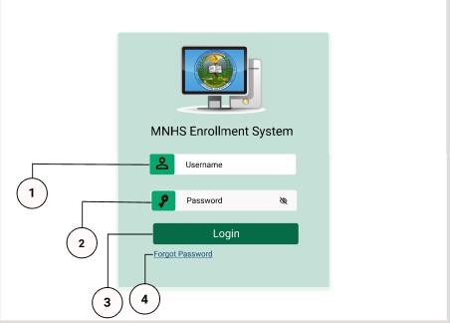

To login as a teacher in the system, the teacher assigned should input the default username (ex: Mery-an_7) and password (Password) and click the login button.

1. Username input field - requires “Administrator” as a default input.
2. Password input field - requires a minimum length of 8 characters and maximum of 16 characters

- should include lowercase and uppercase letters, a number and a special character.

1. Login button - Click to login to the system and be redirected to the admin dashboard.
2. Forgot password - Click the forgot password link and you will be asked to input your mobile number for your account recovery.

# Teacher Profile Setting

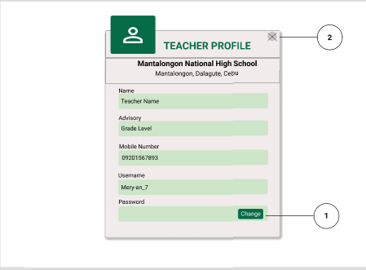

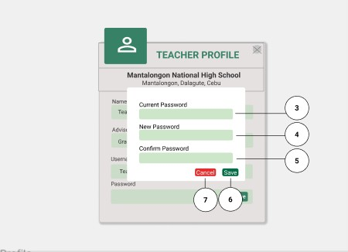

1. Change button - click the button and modal will appear.
2. Close button - click the button and it redirects to the teacher dashboard.
3. Current Password input field - requires the teacher assigned to input the default password.
4. New password input field - requires the teacher assigned to input a strong password (minimum length of 8 characters and maximum of 16 characters, include lowercase and uppercase letters, a number and a special character).
5. Confirm password input field - requires the teacher assigned to input the same value with the new password field.
6. Save button - click the button and it saves the new password and redirects you to the teacher dashboard.
7. Cancel button - click the button and it redirects you to the teacher dashboard.

# Teacher Dashboard Module

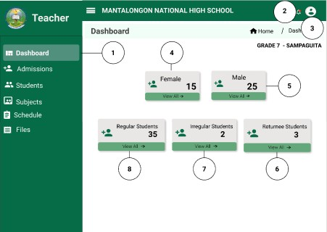

1. Dashboard tab - enables the teacher assigned to see the dashboard content.
2. Notification icon - click the bell and it will display all the subject teachers who give grades to students that are under teacher advisory.
3. User icon - click an icon and it will redirect to the profile settings module.
4. Female card - it shows the total number of female students of your advisory and click the view all and it displays all the list of female students.
5. Male card - it shows the total number of male students of your advisory and click the view all and it displays all the list of male students.
6. Returnee Students card - it shows the total number of returnee students and click view all and it displays the list of returnee students.
7. Irregular Students card - it shows the total number of irregular students and click view all and it displays the list of irregular students.
8. Regular Students card - it shows the total number of regular students and click view all and it displays the list of regular students.

# Admission Module

The module allows the teacher to add a new admission application and it extends to the section designation of the student.

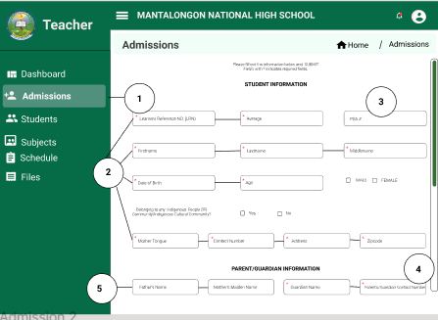

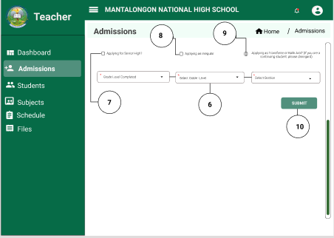

1. Admissions Tab - clicking the tab routes to the page displaying the admission data.
2. Students' information input fields - LRN, average, first name, last name, middle name, date of birth, age, gender, mother tongue, contact number, address, and zip code input fields are required.
3. PSA number input field - it is an optional input field.
4. Parents information input fields - guardian name and guardian contact number are required.
5. Father’s name and Mother’s Maiden name input fields - these two are optional input fields.
6. Grade level completed, Select Grade level and Select Section input fields - these are required input fields.
7. Applying for Senior High box- click the box and it displays all the input fields for senior high students.
8. Apply as Irregular box - click the box and it displays all the input fields for irregular students.
9. Applying for Transferee or Balik Aral box - click the box and it displays all the input fields for irregular students.
10. Submit button - click the button and it saves all the data in the database.

# Students Module

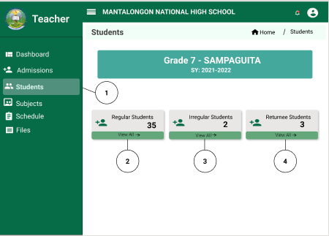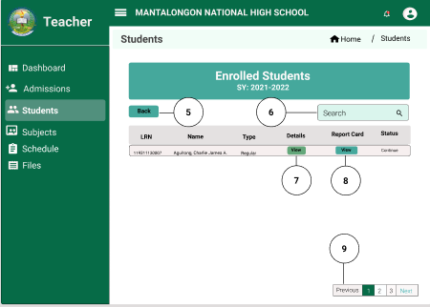

1. Students tab - click the students tab and it will display the three cards.
2. Regular Students card - it shows the total number of regular students and clicking the view all button will display the table of regular students.
3. Irregular Students card - it shows the total number of irregular students and clicking the view all button will display the table of irregular students.
4. Returnee Students card - it shows the total number of returnee students and clicking the view all button will display the table of returnee students.
5. Back button - click the button and it goes back to the card.
6. Search field - input data and click the search icon, it searches the student.
7. View button under details - click the button and it displays the details of the student.
8. View button under Report Card - click the button and it shows the report card of the student.
9. Pagination button - click the previous or next button, it shows another table of student’s data.

**Sections Module**

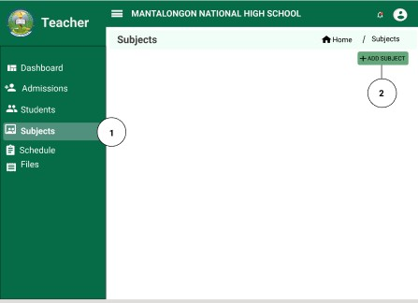

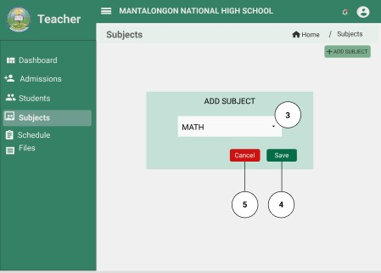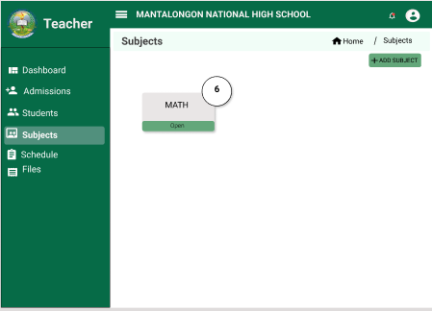

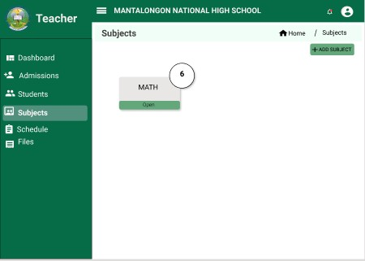

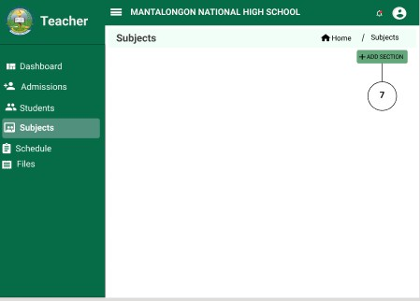

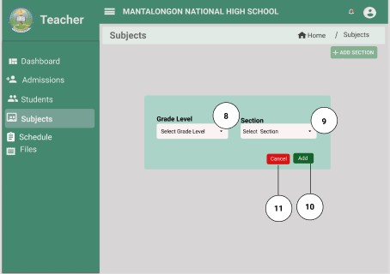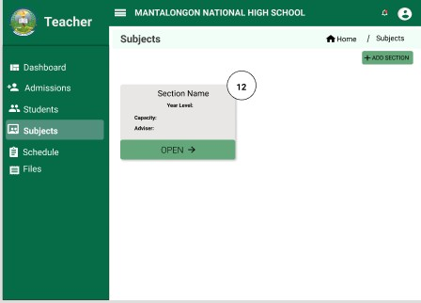

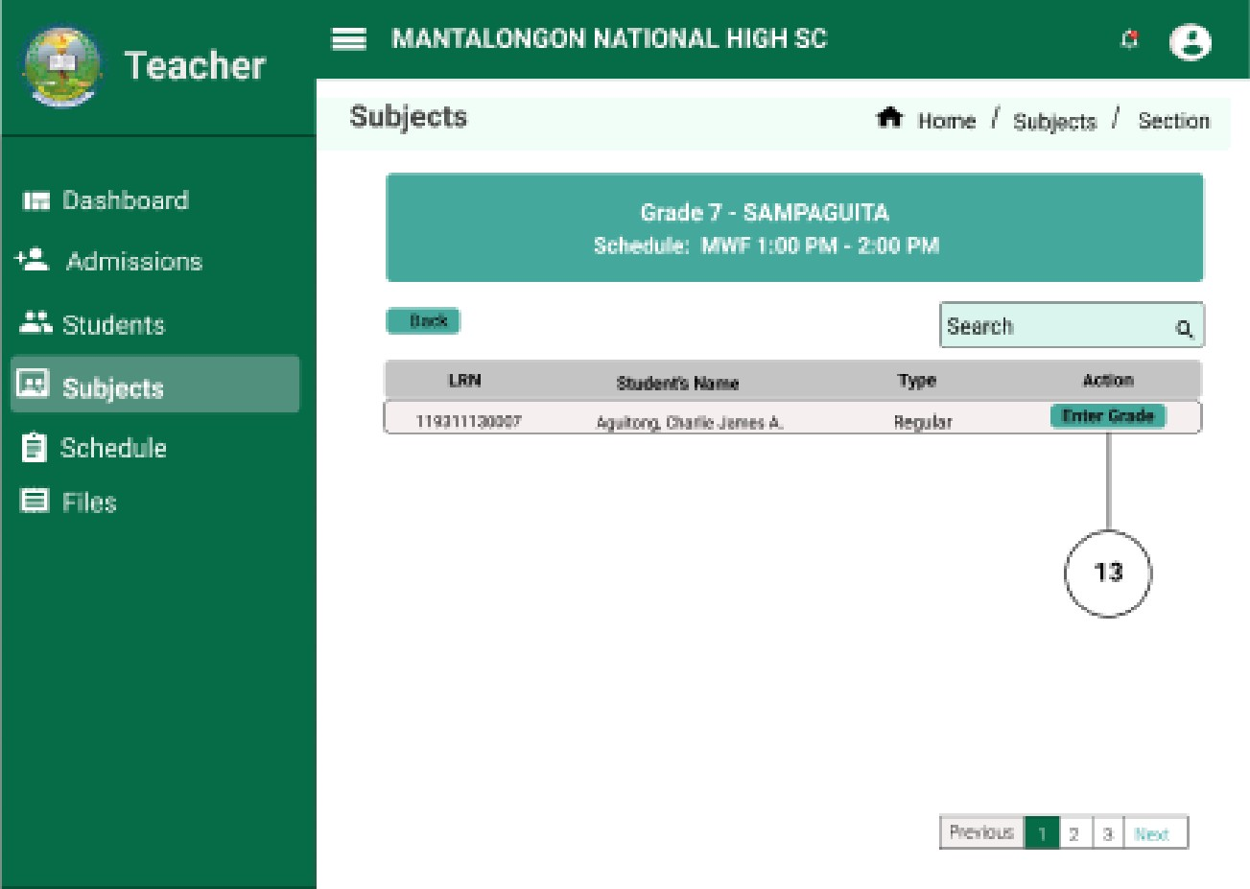

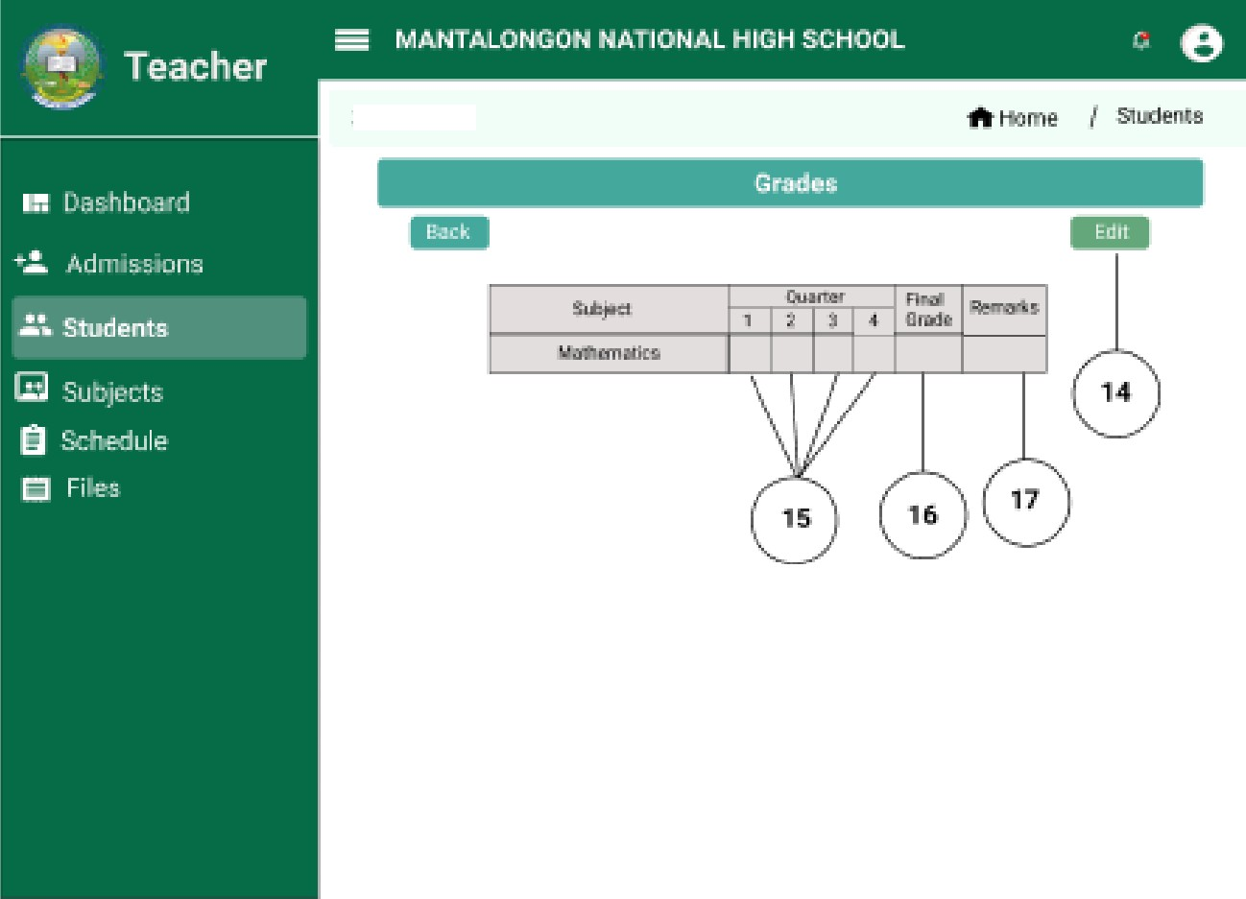

Students

* 1. Subject tab - click the tab and it displays the subjects together with the add subject button.
  2. Add subject button - click the button and modal will appear.
  3. Subject dropdown - click the dropdown arrow to see the subject to be added.
  4. Save button - click the button and it saves the data and will route to the page where all subjects are seen.
  5. Cancel button - click the button and will route to the page where all subjects are seen.
  6. Open button - click the button and it displays the sections and the add section button.
  7. Add section button - click the button and modal will appear.
  8. Dropdown for grade level - click the arrow and it displays the grade level to be selected.
  9. Dropdown for section - click the arrow and it displays the sections to be selected.
  10. Add button - click the button and it adds the data.
  11. Cancel button - click the button and it redirects to the sections that are seen.
  12. Section card - displays the capacity of the sections and adviser and clicks the open button, it will display the table of students.
  13. Enter Grade button - click the button and it displays a table for grading every quarter/semester.
  14. Edict button - click the button and it makes the table editable.
  15. Quarter row - it displays the grade of the student in the specific subject.
  16. Final grade row - it displays the final grade of the student in the subject.
  17. Remarks row - it automatically displays the passed or failed remarks when the final grade is calculated.

# Schedule Module

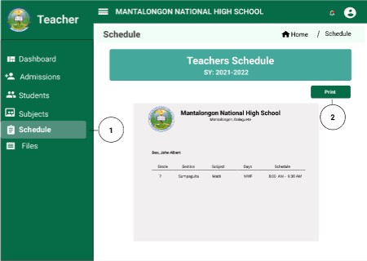

1. Schedule tab - click the tab and it displays the schedule of the teacher in all the subjects she/he handles.
2. Print button - it appears a message to confirm the teacher to print the file.

# https://lh4.googleusercontent.com/UawS97wEqL8cb91YScjiCExmEN6btbPFqp-KdutHfvFUKS9DAdHwTDgkFXVLlsj1KakaK44kWQrkpMbuQzV1r4K2742HIR1yPw7Q5SnGsEQJOsJoMRhJyb2c7FyV3wFiles Module

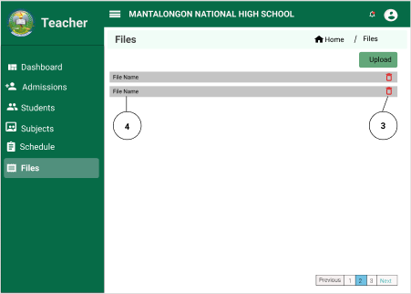

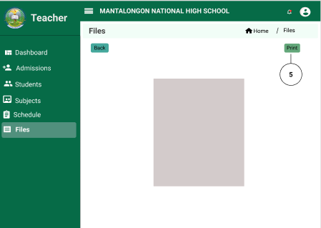

1. Files tab - click the tab and it displays the pdf files uploaded by the teacher.
2. Upload button - click the button and it uploads a pdf file.
3. Delete icon - click the icon and it deletes the file.
4. File name - click the file and it displays the pdf file.
5. Print button -click the button and it appears a message to confirm if the teacher will print the file.

# Non-Advisory Teacher User

**Landing Page**



1. Login button - click the button redirects to the login page where super admin credentials will be asked

# Login Page

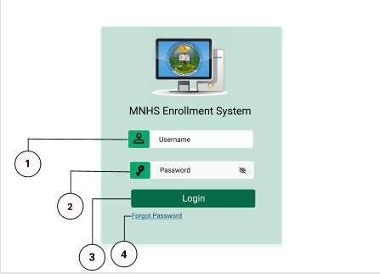To login as a subject teacher in the system, the subject teacher should input the default username (ex: Joselito) and password (Password) and click the login button.

1. Username input field - requires the subject teacher to input the default username.
2. Password input field - requires a minimum length of 8 characters and maximum of 16 characters

- should include lowercase and uppercase letters, a number and a special character

1. Login button - Click to login to the system and be redirected to the subjects tab.
2. Forgot Password - Click the forgot password link and you will be asked to input your mobile number for your account recovery.

# https://lh4.googleusercontent.com/3hCMlvDHOU8kKaHW4GqNuMskGmuIHIifltGYsJmSFpxM7R8XuOvnkgr4gimwYqEA_DsF8p-gfgSLS4IcLmlPO-RqooDvhz-FBP7MDSSTGfb59szed3CsQ8UB87GvQQProfile Setting

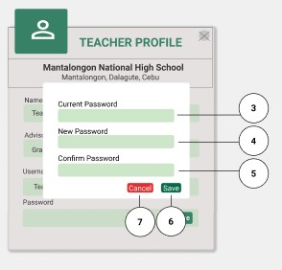

1. Change button - click the button and it appears the modal.
2. Close button - click the button and it redirects to the subject tab.
3. Current Password input field- required to input the current password.
4. New Password input field -requires the subject teacher to input a strong password (minimum length of 8 characters and maximum of 16 characters, include lowercase and uppercase letters, a number and a special character)
5. Confirm Password input field - requires the subject teacher to input the same value with the new password field.
6. Save button - click the button and it saves the data and will redirect the subject teacher to the subject tab.
7. Cancel button - click the button and it redirects to the subject

# Subject Module

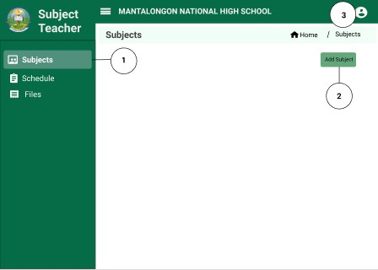

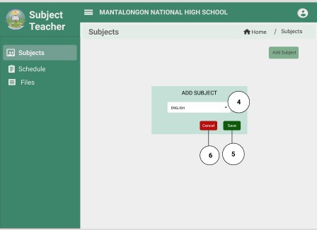

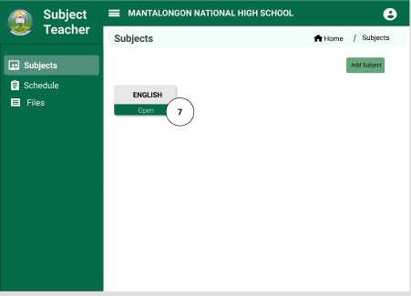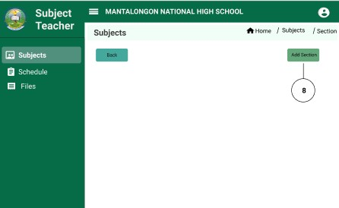

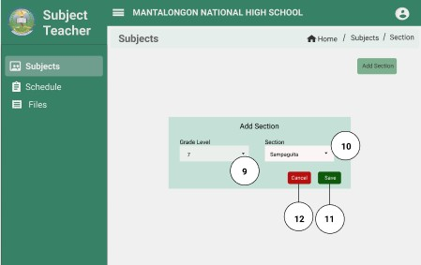

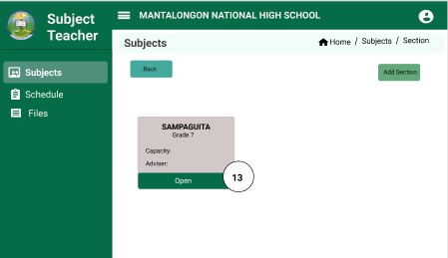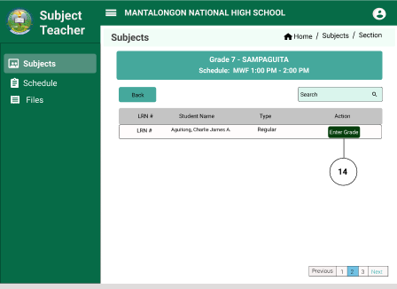

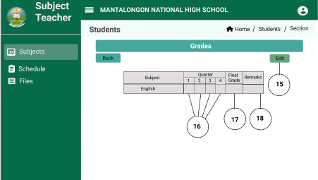

1. Subject tab - it displays all subjects the subject teacher added.
2. Add subject button - click the button and it appears a modal.
3. User icon - click the icon and displays the information of the subject teacher.
4. Dropdown arrow- click the arrow down and display the subject to be added.
5. Save button - it saves the subject and it will display on the card.
6. Cancel button - click the button and it redirects to subjects
7. Open button - click the button and it displays the sections.
8. Add button - click the button and it appears the modal.
9. Grade level dropdown arrow icon - click the icon and display the grade level.
10. Section dropdown arrow icon - click the arrow and display the sessions to be selected.
11. Save button - click the button and it saves the data and redirects to the section.
12. Cancel button - click the button and it returns to the section.
13. Open button - click the button and it displays the table of students.
14. Enter Grade button - click the button and it displays the table for grading.
15. Edit button - click the button and the table for grading will be editable.
16. Quarter row for first quarter to fourth - it displays the grade of the student.
17. Final grade row - displays the final grade of the student.
18. Remarks row - it displays the remarks “Passed” or “Failed”.

# Schedule Module

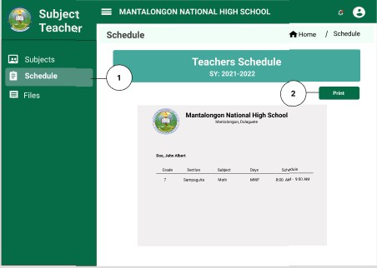

1. Schedule tab - click the tab and display the schedule of the subject teacher.
2. Print button - click the button and alert appears for the confirmation to print.

# Files Module

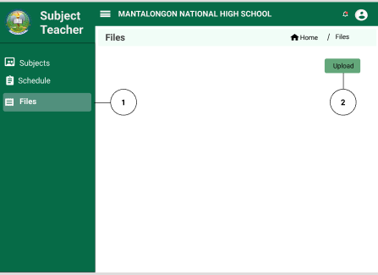

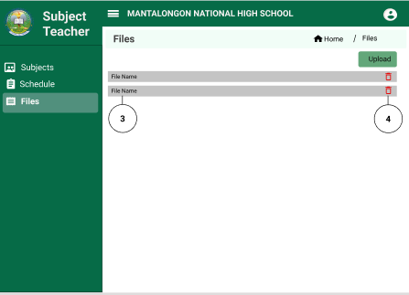

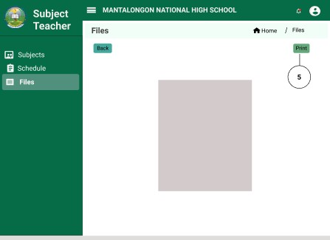

1. Files tab - click the tab and it displays the files uploaded by the subject teacher.
2. Upload button - click the button and it uploads a pdf file.
3. File name - click the file name and it opens the file.
4. Delete icon - click the button and it deletes the file.
5. Print button - click the button and alert appears for the confirmation to print.

# https://lh5.googleusercontent.com/l91N2c4dxJuWuRxEdqASPrwTB6SO9dRATcorEPQLYFmk0g1xHpCv4kCfDGfWSSgPWlesXyphGXLTwU2LGYNHHoR69vlIjRER92C0o-sghJzX6j-KPiEmg_FwEV8FLwCURRICULUM VITAE

**CONTACT INFORMATION**

Name: Ma Justine Bayutas

Address: Rizal, Pinamungajan, Cebu Cell Phone: 09707597087

Email: [mariajustinebayutas@gmail.com](mailto:mariajustinebayutas@gmail.com)

# PERSONAL INFORMATION

Birthday: October 14, 2000 Religion: Roman Catholic Civil Status: Single

# EDUCATIONAL BACKGROUND

University of San Carlos

Certificate in Computer Technology Tertiary Level (2019 – present)

Pinamungajan National High School (PNHS) Secondary Level (2018-2019)

Rizal Elementary School Primary Level (2012-2013)

# TECHNICAL SKILLS

* Knowledge in Javascript, JQuery, HTML, CSS, Java, Php, and Python
* Front-end Frameworks (Bootstrap & Angularjs)
* Database (MySQL & MongoDB)
* Web Designing
* Php Framework (CodeIgniter)

# WORK EXPERIENCE

- Manual Software Quality Assurance Engineer in TrustArc.

# TRAININGS

* Professional Life Training (January 2019 - Present)
* Software Development Training
* Developmental Activity
* Mechatronics (January 2019 - May 2019)

# TRUSTARC TRAININGS

* Mobile Devices Security Training
* HIPAA Privacy for BAs
* Data Security Awareness
* Global Privacy and Data Protection
* Scrum Training
* Introduction to Basic Linux Command

# https://lh6.googleusercontent.com/NSeDb44sVaFsmO7miLHtDKze2Hk0QHY2dlVVcg8gT3JAQ4_DMkAPUll8ni4Ud2QAySYoZz6AkEFTrQMEUasNyoLbd8hD_kLV0jp8iFGKvk6RWl1OkvH1Fo4XMXpuaACURRICULUM VITAE

**CONTACT INFORMATION**

Name: Abdul Azis D. Mamarinta Address: Pinamungajan, Cebu Cell Phone: 09103720212

Email: [mamarinta1099@gmail.com](mailto:mamarinta1099@gmail.com)

# PERSONAL INFORMATION

Birthday: October 10, 1999 Religion: Islam

Civil Status: Single

# EDUCATIONAL BACKGROUND

University of San Carlos

Certificate in Computer Technology Tertiary Level (2019 – present)

Pinamungajan National High School Secondary Level (2018-2019)

Cuneta Elementary School Primary Level (2011-2012)

# TECHNICAL SKILLS

* Knowledge in Javascript, JQuery, HTML, CSS, Java, Php, and Python
* Back-end Frameworks (Laravel)
* Php Framework (CodeIgniter)
* Database (MySQL & MongoDB)

# WORK EXPERIENCE

* ServiceNow Quality Assurance at Accenture Philippines

# TRAININGS

* Professional Life Training (PN Training)
* Software Development Training
* Mechatronics (PN Training)
* Development Activity (PN Training)

# https://lh3.googleusercontent.com/KBcXh8EaLbrEEVDa-fcODWcVE0Xt6EllB1MW9kTNUPz1cVNBeUKdCzKpGkIB3ZKJojcl45SbelvqSI0PBHHDlo_ShDYbtf-zFX7PqZByX5ORyboQliovq-hTScVDnwCURRICULUM VITAE

**CONTACT INFORMATION**

Name: Joselito Monceda

Address: Mantalongon, Dalaguete, Cebu Cell Phone: 09560729025

Email: [joselitomonceda24@gmail.com](mailto:joselitomonceda24@gmail.com)

# PERSONAL INFORMATION

Birthday: December 24, 1999 Religion: Roman Catholic

Civil Status: Single

# EDUCATIONAL BACKGROUND

**University of San Carlos** Certificate in Computer Technology Tertiary Level (2019 – present)

# Mantalongon NAtional High School

Secondary Level (2013 - 2019)

# Langkas Elementary School

Primary Level (2007 - 2013)

# TECHNICAL SKILLS

* Web Designing
  + HTML, CSS, JQuery, Javascript and Bootstrap
* JAVA
* Laravel
* CodeIgniter
* Database Management using Mongo DB and MySQL

# WORK EXPERIENCE

* Project Manager Assistant Intern at Datawords Philippines

# TRAININGS

* **Passerelles Numériques Philippines Trainings**
  + Develop Professionalism | January 2021 - present
  + Mechatronics | January 2019 - May 2019
  + Developmental Activity
  + Software Development

# Datawords Philippines

* + Financial Management Training

# https://lh5.googleusercontent.com/WtW-PwBXMehsop1zLcmgJOh9pZ9dorcA9D967Nj8j-ZE2Y0lmr4tMdhQVIKnwj5e5Ec2okmzwXUiqORvzWQl3UQzneqbZHF2iv4O2gw2B0TPsgMB8PfutLQm5fCT_ACURRICULUM VITAE

**CONTACT INFORMATION**

Name: Mery-an A. Telez

Address: Punod, Pinamungajan, Cebu Cell Phone: 09511321459

Email: [mtelez138@gmail.com](mailto:mtelez138@gmail.com)

# PERSONAL INFORMATION

Birthday: July 31, 1999 Religion: Roman Catholic Civil Status: Single

# EDUCATIONAL BACKGROUND

University of San Carlos

Certificate in Computer Technology Tertiary Level (2019 – present)

Lut-od National High School Secondary Level (2018-2019)

Lut-od Elementary School Primary Level (2012-2013)

# TECHNICAL SKILLS

* Knowledge in Javascript, JQuery, HTML, CSS, Java, Php, and Python
* Front-end Frameworks (Bootstrap & Angularjs)
* Back-end Frameworks (Laravel)
* Database (MySQL & MongoDB)

# WORK EXPERIENCE

* CIO - Source to Pay Intern at Accenture in the Philippines

# TRAININGS

**PASSERELLES NUMÉRIQUES TRAINING**

* Professional Life Training (January 2019 - Present)
* Software Development Training
* Developmental Activity
* Mechatronics (January 2019 - May 2019)

# ACCENTURE TRAINING

* Catch a Phish | September 15, 2021
* Home Defense Diagnostic | September 15, 2021
* Imminent Breach | September 16, 2021
* Security Spring Cleaning | September 16, 2021
* Security Explorer | September 16, 2021
* Prevention of Sexual Harrassment at the Workplace | September 20, 2021
* Information in the Digital Age | September 22, 2021
* Spin for Security | September 22, 2021
* Don’t Get Hooked | September 22, 2021
* Unconscious Bias | September 22, 2021
* Living our Code - Course 1 | October 13, 2021